Pathology Atlas

Pathology Atlas and Notes for Medical Students: See and Learn

Serdar Balcı

Pathologists, Assistants and Technicians

2023-07-01

Pathology Atlas and Notes for Medical Students: See and Learn Pathology Lecture Notes and Pathology Atlas is being prepared from Memorial Pathology Archive and collaborators from other institutions. If you want to contribute, please [contact us](https://www.patolojiatlasi.com/katki.html).

Table of contents

# Patoloji Atlası

[Türkçe Atlas için tıklayın](https://www.patolojiatlasi.com/)

For social media based pathology notes [click here](https://www.patolojinotlari.com/)

# Giriş

Patoloji Atlası Memorial Patoloji arşivinden ve diğer kurumlardan katkı yapan meslektaşlarımızın kolleksiyonlarından oluşmaktadır.

[Katkı yapmak ve kendi vakalarınız ekletmek için lütfen iletişime geçin](https://www.patolojiatlasi.com/katki.html).

Son güncelleme zamanı: 2023-07-01 16:49:43.888062

Sosyal medyadan derlenen görüntülerden oluşan [patoloji notları için tıklayınız](https://www.patolojinotlari.com/).

# Authors and Contributors

## Editor:

* [Serdar Balcı](https://www.serdarbalci.com)

## Contributors:

[**Memorial Pathology**](https://patoloji.memorial.com.tr/) **Physicians**

* [İlknur Turkmen](https://www.memorial.com.tr/en/doctors/ilknur-turkmen-1975)
* [Gülen Bülbül Doğusoy](https://www.memorial.com.tr/doktorlar/gulen-bulbul-dogusoy)
* [Fatma Aktepe](https://www.memorial.com.tr/doktorlar/fatma-aktepe)
* [Türkan Atasever Rezanko](https://www.memorial.com.tr/doktorlar/turkan-atasever-rezanko)
* [Pembe Gül Güneş](https://www.memorial.com.tr/doktorlar/pembe-gul-gunes)
* [Şemsi Yıldız](https://www.memorial.com.tr/doktorlar/semsi-yildiz)
* [Serdar Balcı](https://www.memorial.com.tr/doktorlar/serdar-balci-k)
* [Sezen Koçarslan](https://www.memorial.com.tr/doktorlar/sezen-kocarslan)
* [Yıldırım Karslıoğlu](https://www.memorial.com.tr/doktorlar/yildirim-karslioglu)
* [Mehtat Uz Ünlü](https://www.memorial.com.tr/doktorlar/mehtat-uz-unlu)
* [Murat Oktay](https://www.memorial.com.tr/doktorlar/murat-oktay)
* [Deniz Bayçelebi](https://www.memorial.com.tr/doktorlar/deniz-baycelebi)
* [Emre Karakök](https://www.memorial.com.tr/doktorlar/emre-karakok)
* [Zuhal Kuş Sılav](https://www.memorial.com.tr/doktorlar/zuhal-kus-silav)
* [Fatma Gülgün Sade Koçak](https://www.memorial.com.tr/doktorlar/fatma-gulgun-sade-kocak)
* [Zeynep Pehlivanoğlu](https://www.memorial.com.tr/doktorlar/zeynep-pehlivanoglu)

[**Memorial Pathology**](https://patoloji.memorial.com.tr/) **Pathology Assistants**

* [Emrah Uça]
* [Şevin Elif Şanioğlu](https://www.linkedin.com/in/%C5%9Fevin-elif-%C5%9Fanio%C4%9Flu-99449a1b0/)
* [Baset Sığırcı](https://www.linkedin.com/in/baset-s%C4%B1%C4%9F%C4%B1rc%C4%B1-aa2406141/)
* [Rabia Öztürk](https://www.linkedin.com/in/rabia-%C3%B6zt%C3%BCrk-4989b3151/)
* [Zehra Yaşaroğlu]
* [Baha Erdoğan]
* [Talha Akbaş]

## Contributors from Other Institutions

* [Tarık Atmaca](https://github.com/veterinarypathology3d)
* [Kemal Kösemehmetoğlu](https://hacettepepathology.com/)
* [Arzu Sağlam Ayhan](https://www.hastane.hacettepe.edu.tr/115.html?drid=479)
* [Burcu Saka](https://scholar.google.com.tr/citations?user=9e7r9yQAAAAJ)
* [İpek Çoban Elbeği](https://www.florence.com.tr/prof-dr-ipek-coban-elbegi)

# 1. Techniques Used in Pathology

## 1.1 Histochemistry

### 1.1.1 Mucin

#### Mucicarmine

**mucicarmine histochemistry stain showing intracellular mucin in a normal colon**

[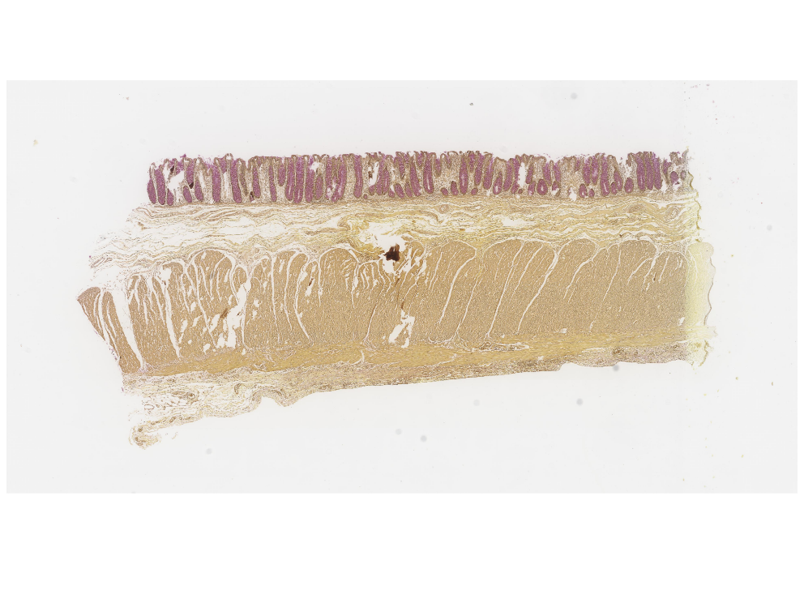](https://images.patolojiatlasi.com/mucin/mucicarmine.html) [Click for Full Screen WSI](https://images.patolojiatlasi.com/mucin/mucicarmine.html)

## 1.2 Chromogenic in situ hybridization (CISH)

**Chromogenic in situ hybridization (CISH)**

[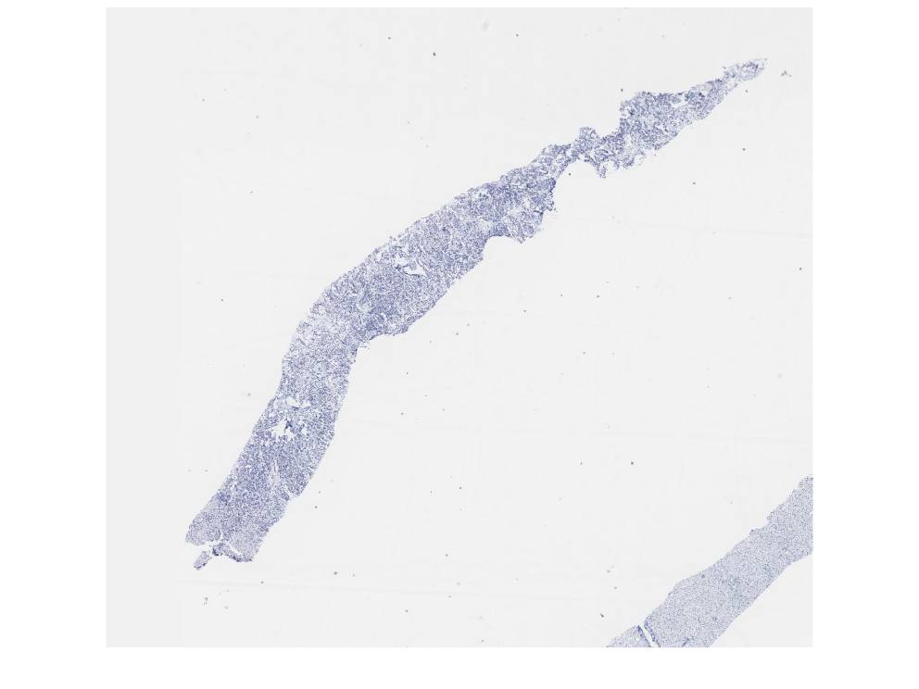](https://images.patolojiatlasi.com/her-cish/cish.html) [Click for Full Screen WSI](https://images.patolojiatlasi.com/her2-cish/cish.html)

# 2. Hücre İçi Birikimler

## 2.1 Cholesterol Polyp

**Cholesterol Polyp**

[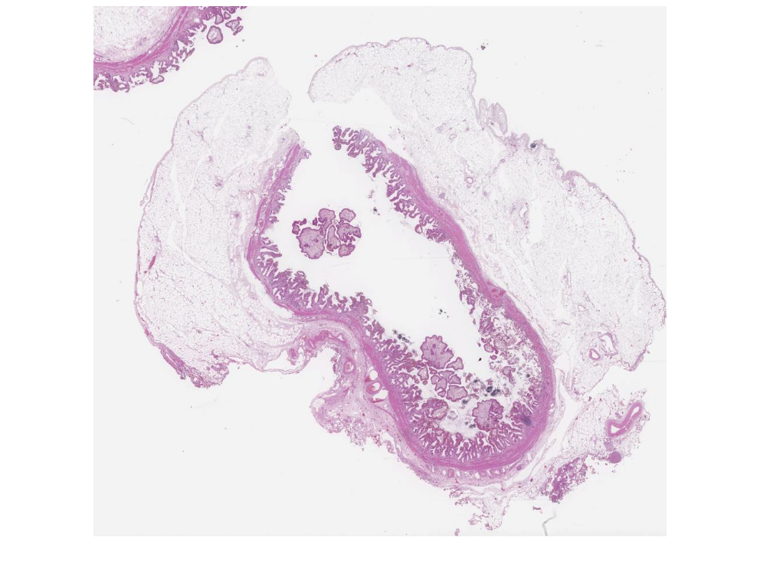](https://images.patolojiatlasi.com/cholesterolpolyp/HE.html) [Click for Full Screen WSI](https://images.patolojiatlasi.com/cholesterolpolyp/HE.html)

## 2.2 Glycogen Storage Disease

**Karaciğer İğnde Biyopsisinde glikojen depo hastalığı**

**Hematoksilen Eozin**

[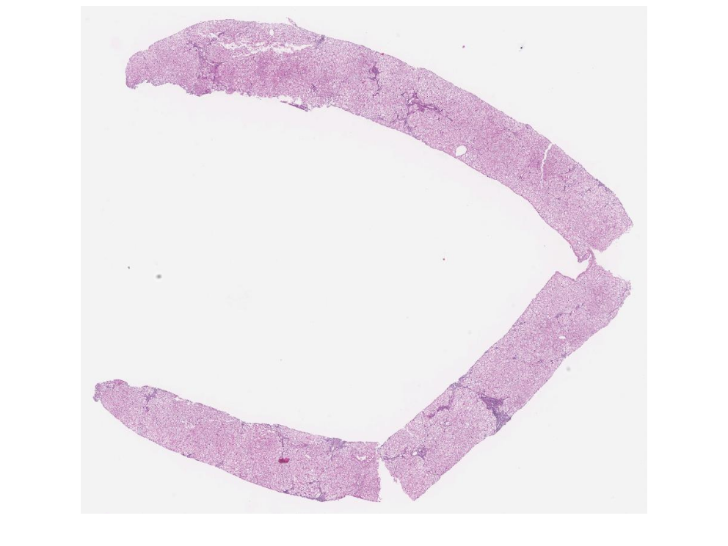](https://images.patolojiatlasi.com/glycogenstorage/HE.html) [Tam Ekran Görmek İçin Resmi Tıklayın](https://images.patolojiatlasi.com/glycogenstorage/HE.html)

**PAS**

[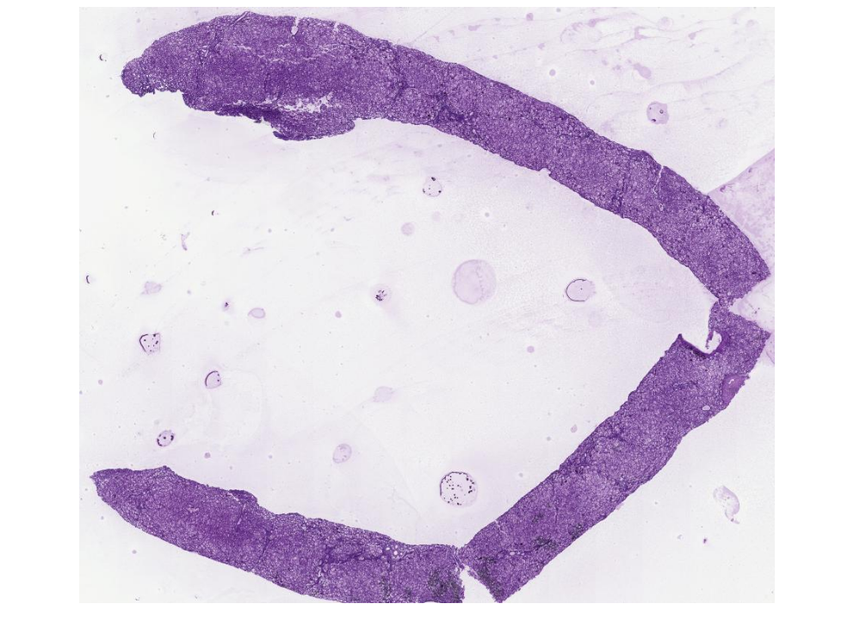](https://images.patolojiatlasi.com/glycogenstorage/PAS.html) [Tam Ekran Görmek İçin Resmi Tıklayın](https://images.patolojiatlasi.com/glycogenstorage/PAS.html)

**PASD**

[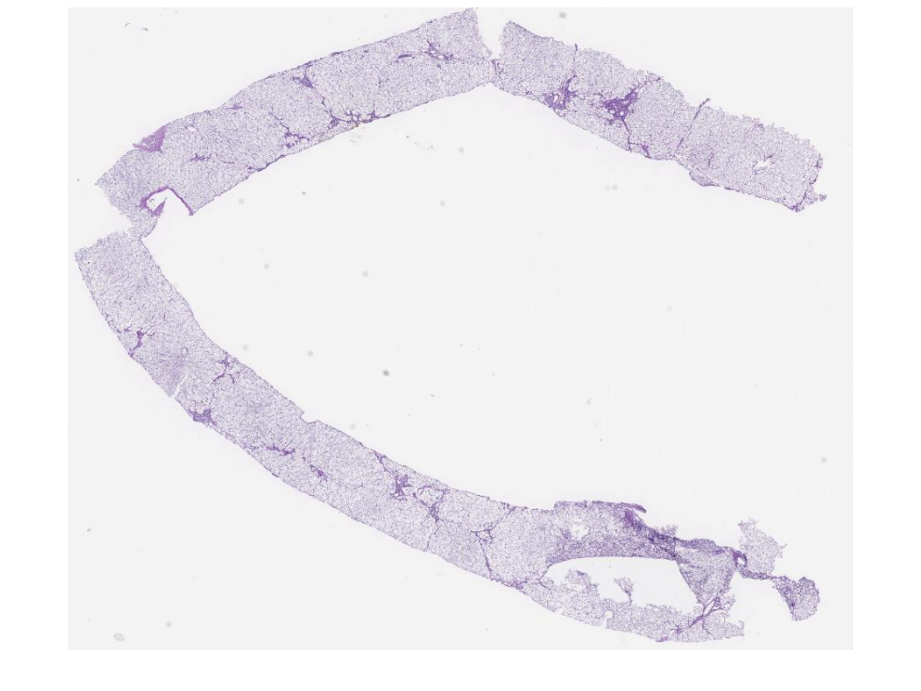](https://images.patolojiatlasi.com/glycogenstorage/PASD.html) [Tam Ekran Görmek İçin Resmi Tıklayın](https://images.patolojiatlasi.com/glycogenstorage/PASD.html)

## 2.3 Antrakoz, Antrakotik Pigment

Torakal bölge lenf nodunda antrakotik pigment

[](https://images.patolojiatlasi.com/template/HE.html) [Click for Full Screen WSI](https://images.patolojiatlasi.com/anthracosis/HE.html)

[](https://images.patolojiatlasi.com/template/HE.html) [Click for Full Screen WSI](https://images.patolojiatlasi.com/anthracosis/HE2.html)

## 2.4 Melanosis Coli

**Melanosis Coli**

[](https://images.patolojiatlasi.com/template/HE.html) [Click for Full Screen WSI](https://images.patolojiatlasi.com/melanosiscoli/HE.html)

**Melanosis Coli PAS**

[](https://images.patolojiatlasi.com/template/HE.html) [Click for Full Screen WSI](https://images.patolojiatlasi.com/melanosiscoli/PAS.html)

# 3. Hücre Dışı Birikimler

## 3.1 Ochronosis

**Ochronosis**

[](https://images.patolojiatlasi.com/template/HE.html) [Click for Full Screen WSI](https://images.patolojiatlasi.com/ochronosis/HE.html)

# 4. Cellular Injury

## 4.1 Reactive atypia in an ulcerated colon polyp

**Reactive atypia in an ulcerated colon polyp**

[](https://images.patolojiatlasi.com/template/HE.html) [Click for Full Screen WSI](https://images.patolojiatlasi.com/reactive-atypia/HE.html)

# 5.

# 6. İnflamasyon

# 7. Congo Red

**Congo Red stain for amyloidosis**

[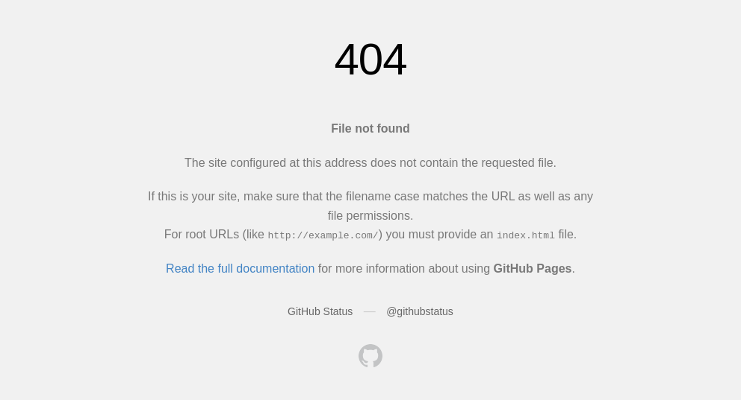](https://images.patolojiatlasi.com/congored/congored.html) [Tam Ekran Görmek İçin Resmi Tıklayın](https://images.patolojiatlasi.com/congored/congored.html)

## 7.1 Congo Red Birefringence

<https://www.youtube.com/watch?v=U9glkfQLTm4>

**Congo Red Birefringence**

[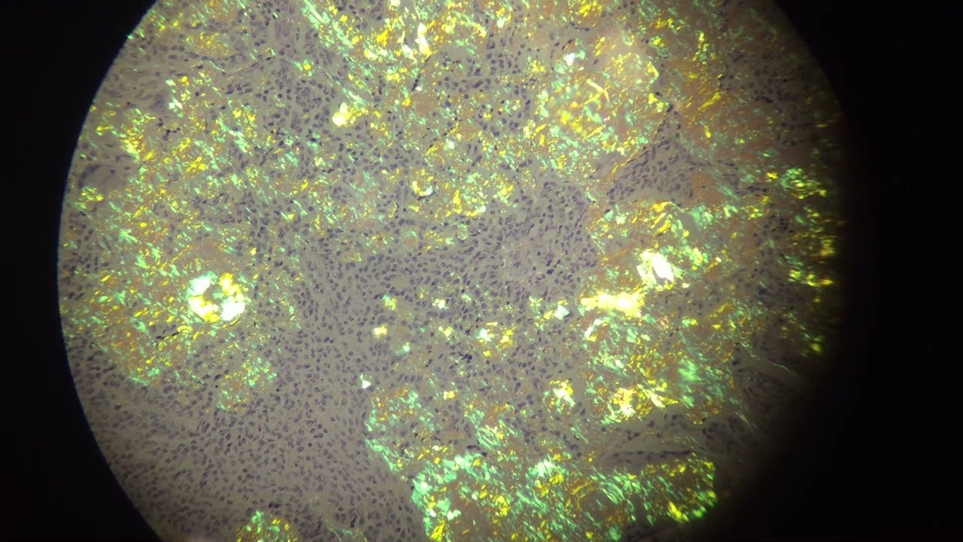](https://www.youtube.com/watch?v=U9glkfQLTm4) [Video İçin Tıklayın](https://www.youtube.com/watch?v=U9glkfQLTm4)

# 8. Tamir Mekanizmaları

Bu sayfadaki görüntülere artırılmış gerçeklik (augmented reality) ile de ulaşabilirsiniz[1].

Karekodu cep telefonunuza okutun:

|  |
| --- |
|  |

Link ile açılan sayfaya ve kamera erişimine izin verin. Sonra kamerayı bu sayfadaki patoloji resimlerine tutun. Tanılar cep telefonunuzda görünecektir.

<https://www.youtube.com/watch?v=76bOJIiT29Y>

## 8.1 Fibrozis

Kolesistit spesmeninde gelişmekte olan genç fibrozis

[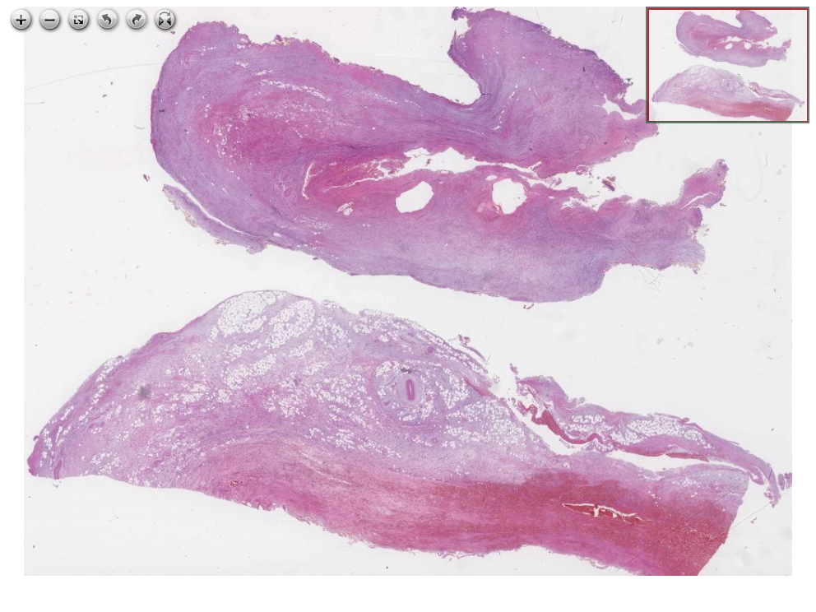](https://images.patolojiatlasi.com/fibrosis/HE.html) [Tam Ekran Görmek İçin Resmi Tıklayın](https://images.patolojiatlasi.com/fibrosis/HE.html)

## 8.2 Keloid - Skar

Keloid Skar oluşumu

[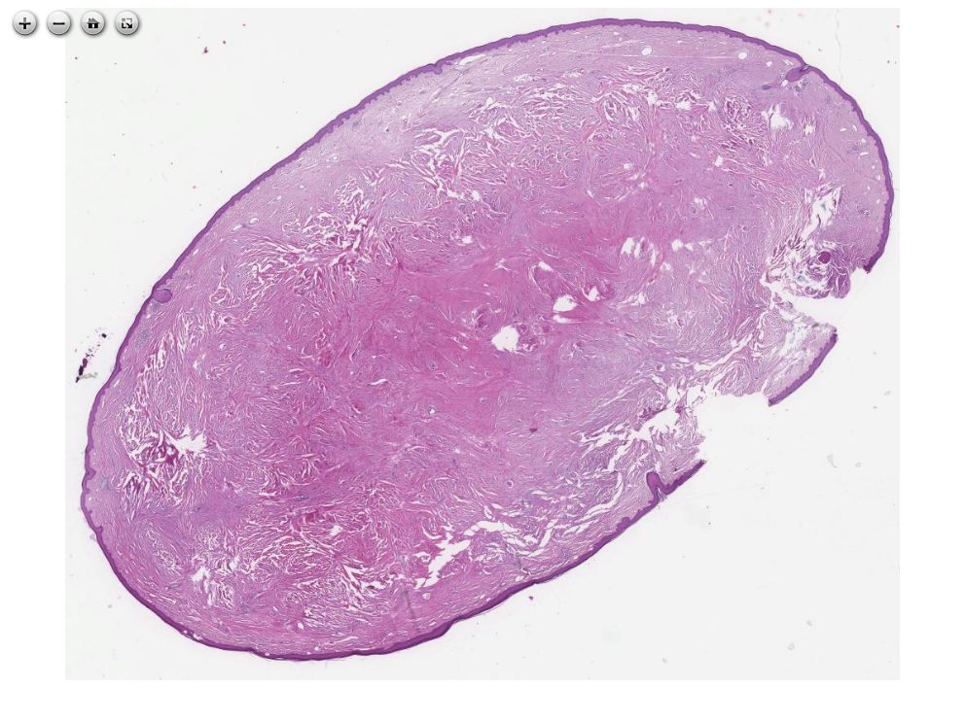](https://images.patolojiatlasi.com/keloid-scar/HE.html) [Tam Ekran Görmek İçin Resmi Tıklayın](https://images.patolojiatlasi.com/keloid-scar/HE.html)

# 9. Erosion

## 9.1 Erosion in Gastric Mucosa

**Erosion in Gastric Mucosa**

[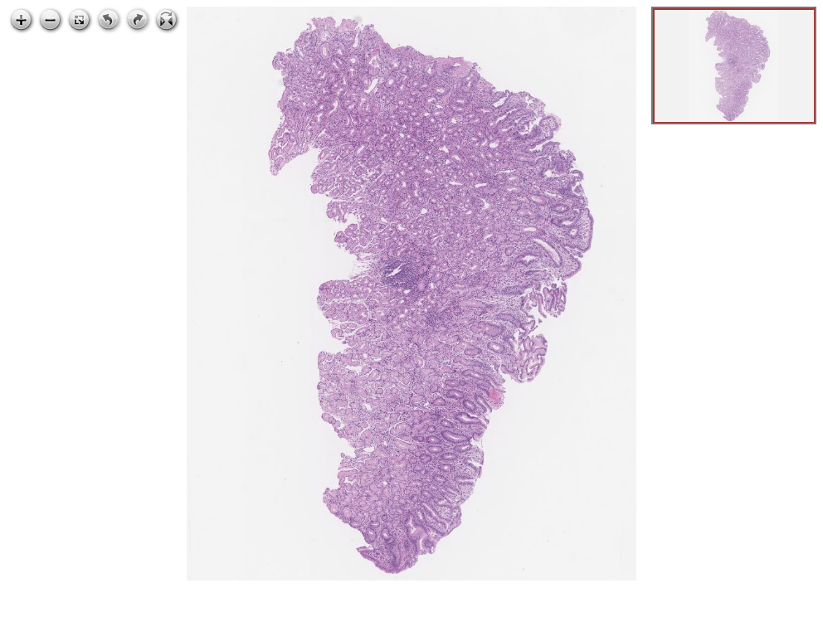](https://images.patolojiatlasi.com/erosion/HE.html) [Click for Full Screen WSI](https://images.patolojiatlasi.com/erosion/HE.html)

# 10. Acute Inflammation

## 10.1 Acute Appendicitis

**Acute appendicitis**

[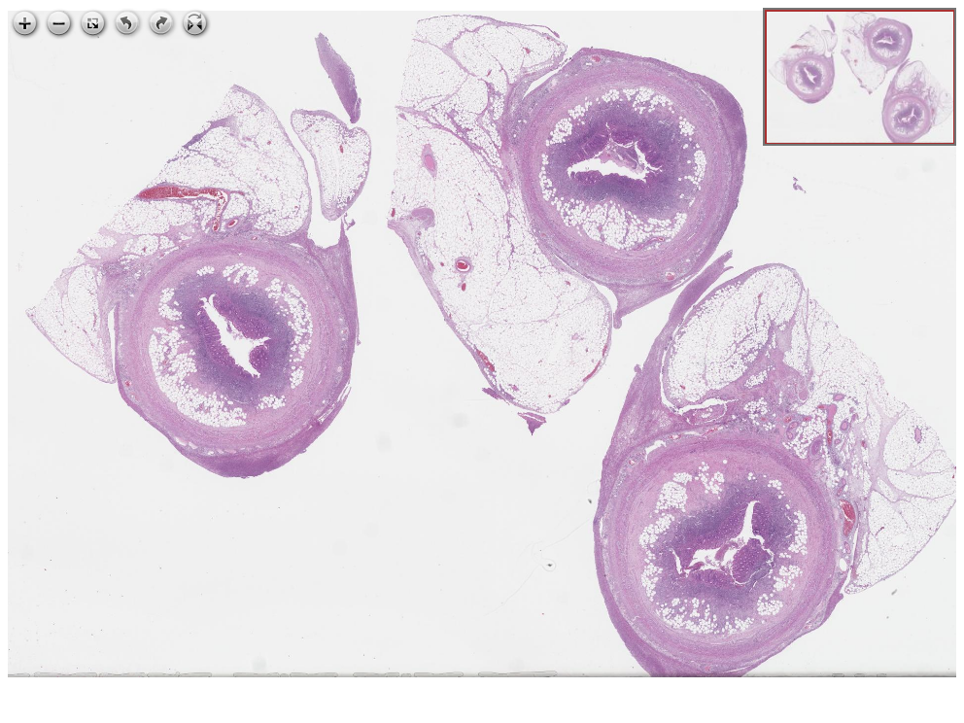](https://images.patolojiatlasi.com/acute-appendicitis/HE.html) [Click for Full Screen WSI](https://images.patolojiatlasi.com/acute-appendicitis/HE.html)

# 11. Chronic Inflammation

## 11.1 Hydronephrosis and Chronic Pyelonephritis

**Hydronephrosis and Chronic Pyelonephritis**

[](https://images.patolojiatlasi.com/template/HE.html) [Click for Full Screen WSI](https://images.patolojiatlasi.com/chronicpyelonephritis/HE1.html)

## 11.2 Chronic Pyelonephritis

**Chronic Pyelonephritis**

[](https://images.patolojiatlasi.com/template/HE.html) [Click for Full Screen WSI](https://images.patolojiatlasi.com/chronic-pyelonephritis/HE.html)

# 12. Granulomatous Inflammation

## 12.1 Necrotising Granulomatous Inflammation

**Necrotising Granulomatous Inflammation in Liver**

[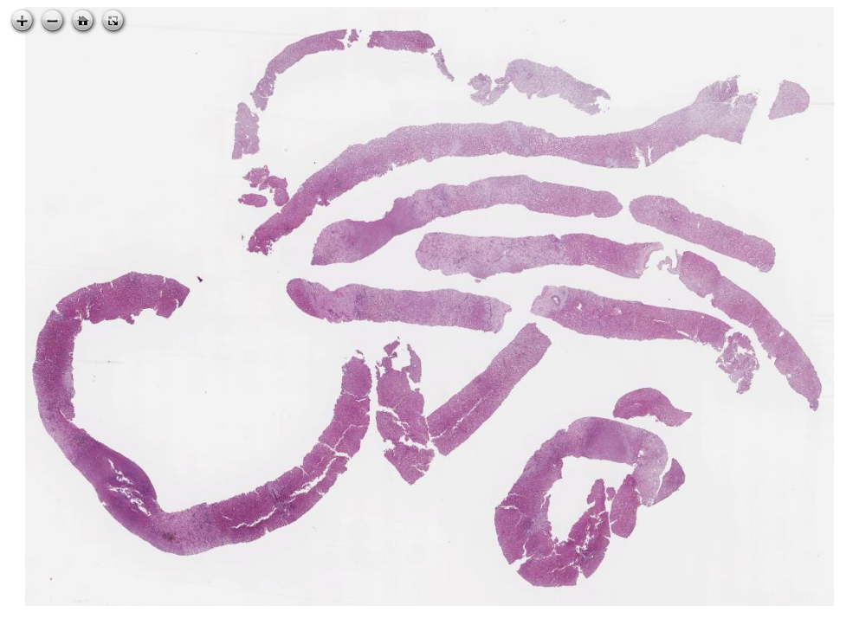](https://images.patolojiatlasi.com/necrotisinggranuloma/HE.html) [Click for Full Screen WSI](https://images.patolojiatlasi.com/necrotisinggranuloma/HE.html)

# 13. Virus

## 13.1 Herpes Simplex Virus (HSV)

### 13.1.1 Herpes Esophagatis

### 13.1.2 Herpes Özofajiti

[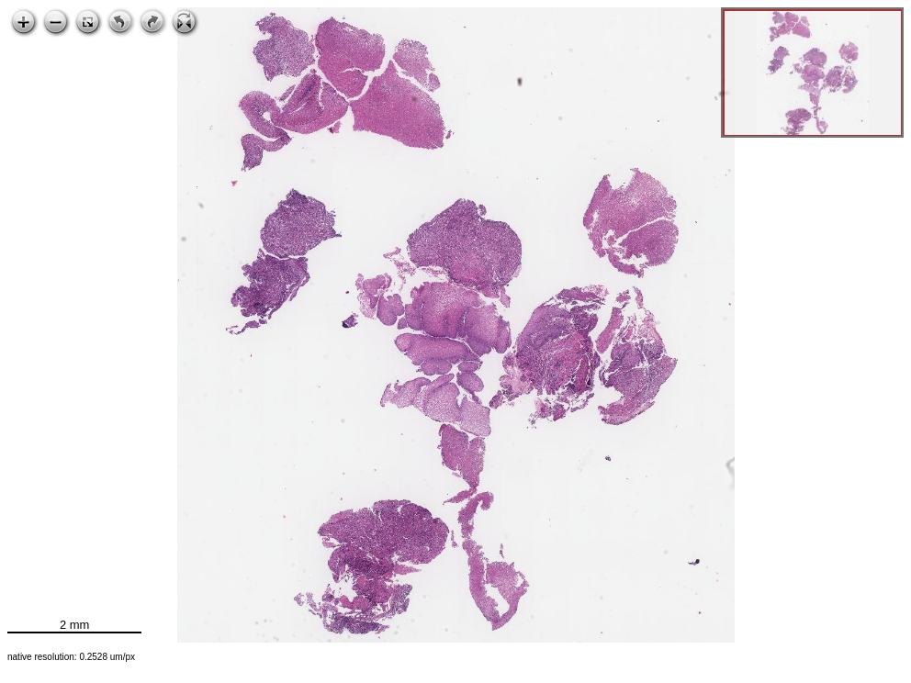](https://images.patolojiatlasi.com/HSV/herpesesophagitis/viewer_z0.html) [Click for Full Screen WSI](https://images.patolojiatlasi.com/HSV/herpesesophagitis/viewer_z0.html)

## 13.2 Molluscum contagiosum

**Molluscum contagiosum**

[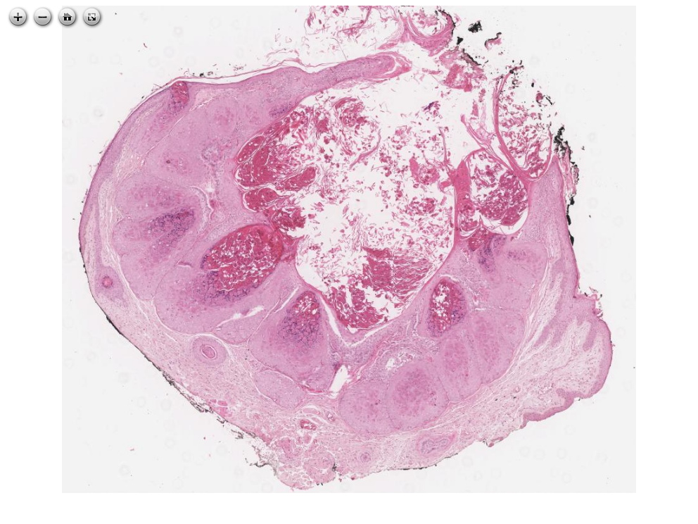](https://images.patolojiatlasi.com/molluscum-contagiosum/HE.html) [Click for Full Screen WSI](https://images.patolojiatlasi.com/molluscum-contagiosum/HE.html)

# 14. Bacteria

## 14.1 Helicobacter pylori

**Helicobacter pylori (H. pylori) in stomach HE Slide**

[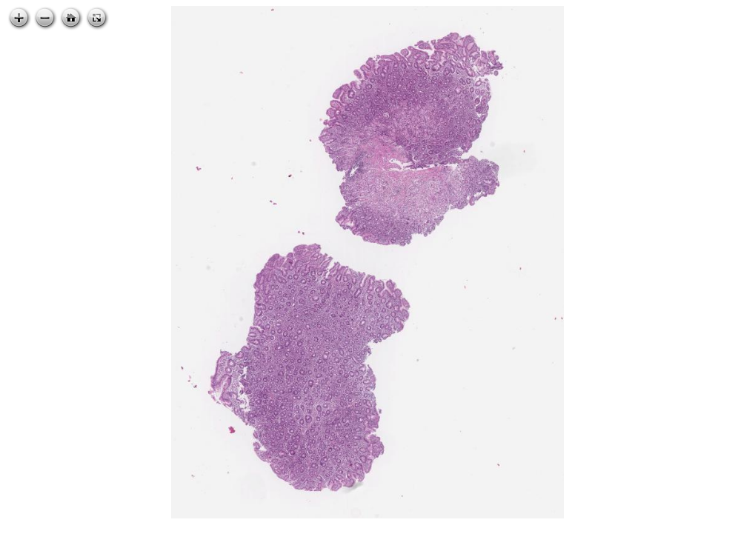](https://images.patolojiatlasi.com/helicobacterpylori/HE.html) [Click for Full Screen WSI](https://images.patolojiatlasi.com/helicobacterpylori/HE.html)

**Helicobacter pylori (H. pylori) in stomach Warthin Starry Histochemistry Slide**

[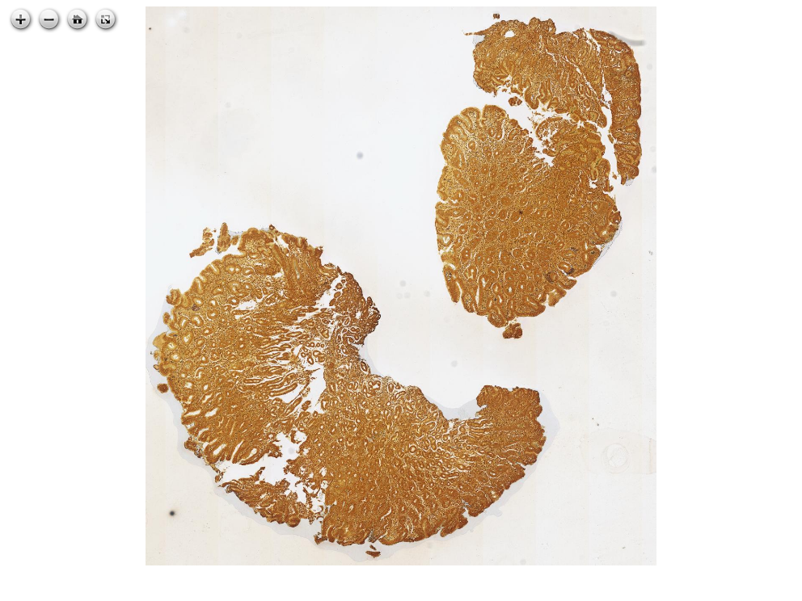](https://images.patolojiatlasi.com/helicobacterpylori/warthinstarry.html) [Click for Full Screen WSI](https://images.patolojiatlasi.com/helicobacterpylori/warthinstarry.html)

**Helicobacter pylori (H. pylori) in stomach Giemsa Histochemistry Slide**

[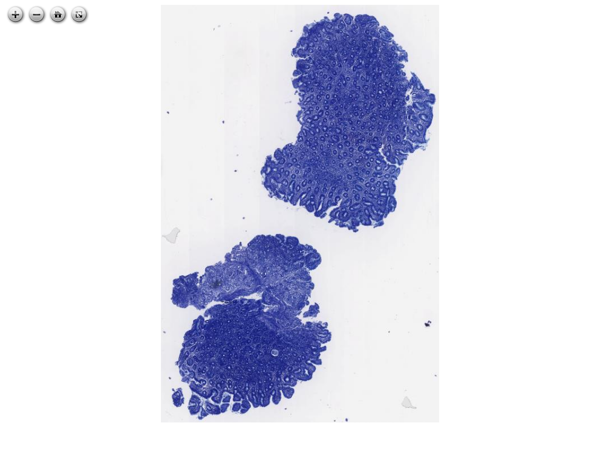](https://images.patolojiatlasi.com/helicobacterpylori/giemsa.html) [Click for Full Screen WSI](https://images.patolojiatlasi.com/helicobacterpylori/giemsa.html)

**Helicobacter pylori (H. pylori) immunohistochemistry in stomach**

[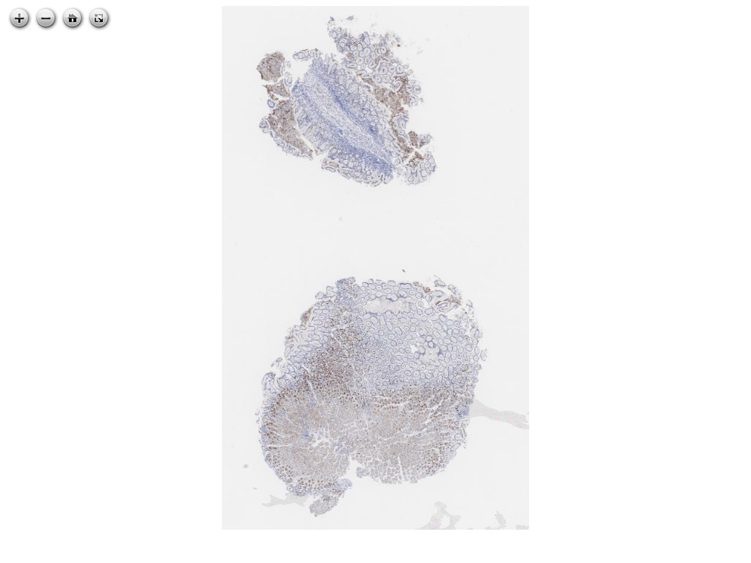](https://images.patolojiatlasi.com/helicobacterpylori/IHC.html) [Click for Full Screen WSI](https://images.patolojiatlasi.com/helicobacterpylori/IHC.html)

# 15. Mantarlar

## 15.1 Candida *albicans* in cervicovaginal smear

print("repeating content")

[1] "repeating content"

[](https://images.patolojiatlasi.com/template/HE.html) [Tam Ekran Görmek İçin Resmi Tıklayın](https://images.patolojiatlasi.com/candidaalbicans/cervicovaginalsmear/viewer_z0.html)

## 15.2 Brain mucormycosis

**brain mucormycosis HE**

[](https://images.patolojiatlasi.com/template/HE.html) [Click for Full Screen WSI](https://images.patolojiatlasi.com/brain-mucormycosis/HE.html)

**brain mucormycosis GMS**

[](https://images.patolojiatlasi.com/template/HE.html) [Click for Full Screen WSI](https://images.patolojiatlasi.com/brain-mucormycosis/HE.html)

# 16. Parasites

## 16.1 Enterobius vermicularis

**Enterobius vermicularis**

[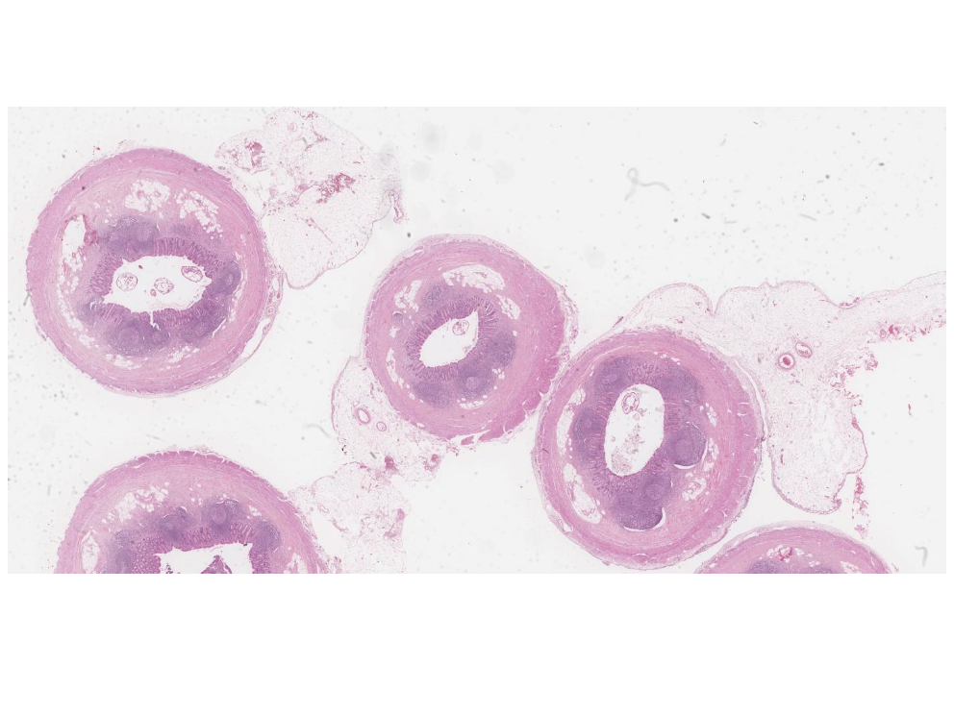](https://images.patolojiatlasi.com/enterobius-vermicularis/HE.html) [Click for Full Screen WSI](https://images.patolojiatlasi.com/enterobius-vermicularis/HE.html)

# 17. Benign Tumors

## 17.1 Adenoma

### 17.1.1 Tubular Adenoma

#### Sesile Polyp, Flat Tubular Adenoma

#### Polyp with Stalk

Macroscopy

[tubular adenoma with a stalk macroscopy](https://images.patolojiatlasi.com/tubularadenoma/tubular-adenoma-with-stalk-macroscopy.jpg)

Microscopy

[tubular adenoma with a stalk](https://images.patolojiatlasi.com/tubularadenoma/tubular-adenoma-with-stalk.jpeg)

# 18. Hamartom

## 18.1 Hamartomatöz Polip

[](https://images.patolojiatlasi.com/template/HE.html) [Tam Ekran Görmek İçin Resmi Tıklayın](https://images.patolojiatlasi.com/hamartomatouspolyp/HE.html)

## 18.2 Schwann Cell Hamartoma in a Colon Polyp

[](https://images.patolojiatlasi.com/template/HE.html) [Tam Ekran Görmek İçin Resmi Tıklayın](https://images.patolojiatlasi.com/schwanncellhamartoma/HE.html)

# 19. Heterotopi Ektopi

## 19.1 Intrapancreatic Spleen, Heterotopia

[](https://images.patolojiatlasi.com/template/HE.html) [Tam Ekran Görmek İçin Resmi Tıklayın](https://images.patolojiatlasi.com/intrapancreaticspleen/HE.html)

## 19.2 Ectopic adrenal tissue in paratubal adnexal region

**Ectopic adrenal tissue in paratubal adnexal region**

[](https://images.patolojiatlasi.com/template/HE.html) [Click for Full Screen WSI](https://images.patolojiatlasi.com/ectopic-adrenal/HE.html)

# 20. Metaplasia

## 20.1 Pancreatic Acinar Metaplasia, Stomach

**Pancreatic Acinar Metaplasia, Stomach**

[](https://images.patolojiatlasi.com/template/HE.html) [Click for Full Screen WSI](https://images.patolojiatlasi.com/metaplasia/HE.html)

# 21. Carcinogenesis

## 21.1 metaplasia, dysplasia, carcinoma

**metaplasia, dysplasia, carcinoma**

[](https://images.patolojiatlasi.com/template/HE.html) [Click for Full Screen WSI](https://images.patolojiatlasi.com/carcinogenesis/HE.html)

# 22. Features of Malignancy

## 22.1 Pleomorphism

**Pleomorphism**

[](https://images.patolojiatlasi.com/template/HE.html) [Click for Full Screen WSI](https://images.patolojiatlasi.com/pleomorphism/HE.html)

# 23. Metastaz

## 23.1 Karaciğerde Sarkom Metastazı

[](https://images.patolojiatlasi.com/template/HE.html) [Tam Ekran Görmek İçin Resmi Tıklayın](https://images.patolojiatlasi.com/metastaticsarcoma/HE.html)

## 23.2 Insidious lymph node metastasis

**Sinsi bir lenf nodu metastazı OSKAR panCK**

[](https://images.patolojiatlasi.com/template/HE.html) [Tam Ekran Görmek İçin Resmi Tıklayın](https://images.patolojiatlasi.com/insidious-lymph-node-metastasis/OSKARCK.html)

**insidious lymph node metastasis HE**

[](https://images.patolojiatlasi.com/template/HE.html) [Click for Full Screen WSI](https://images.patolojiatlasi.com/insidious-lymph-node-metastasis/HE.html)

# 24. Tumor Spread to Other Organs

## 24.1 Colon tumor spread to cervix

**Colon tumor spread to cervix**

[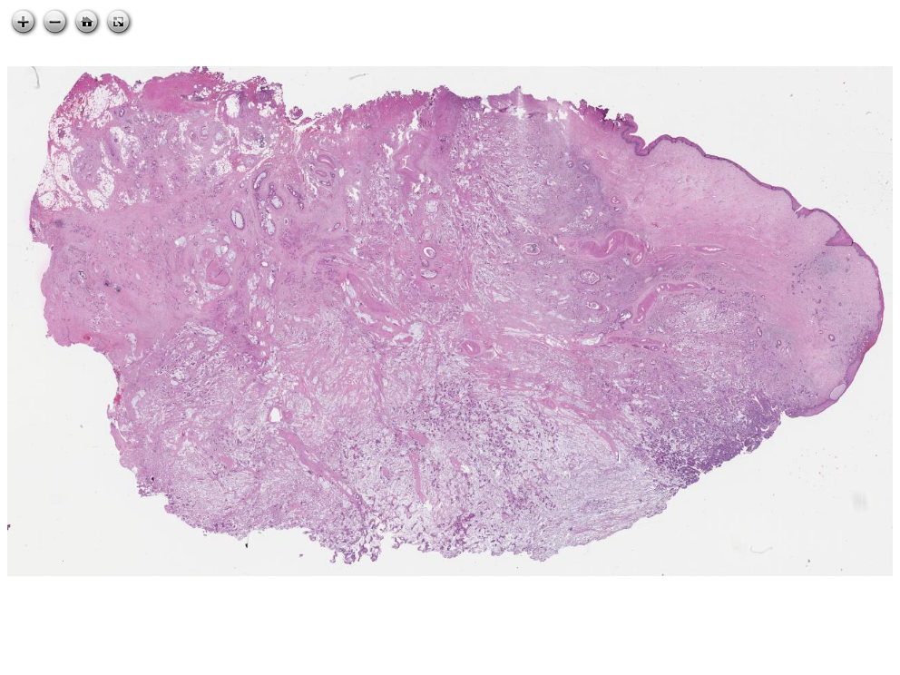](https://images.patolojiatlasi.com/tumor-spread/HE-cervix.html) [Click for Full Screen WSI](https://images.patolojiatlasi.com/tumor-spread/HE-cervix.html)

## 24.2 Colon tumor spread to endometrium

**Colon tumor spread to endometrium**

[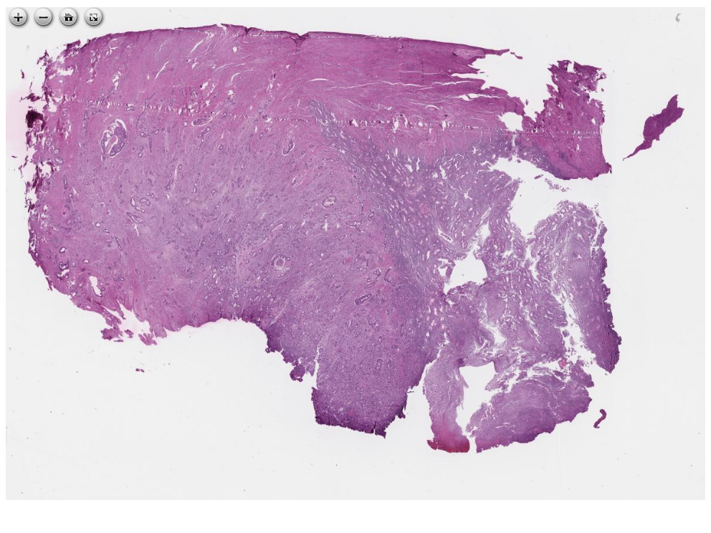](https://images.patolojiatlasi.com/tumor-spread/HE-endometrium.html) [Click for Full Screen WSI](https://images.patolojiatlasi.com/tumor-spread/HE-endometrium.html)

## 24.3 Colon tumor spread to over

**Colon tumor spread to over**

[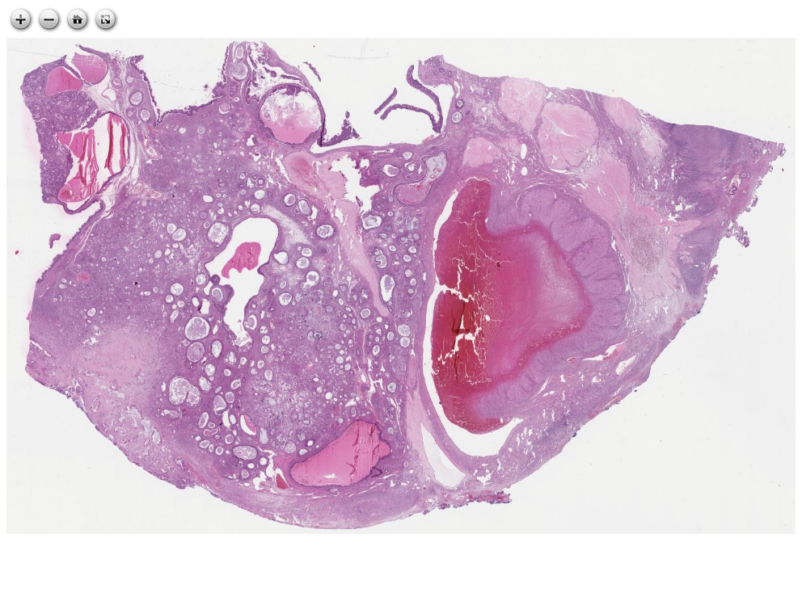](https://images.patolojiatlasi.com/tumor-spread/HE-over.html) [Click for Full Screen WSI](https://images.patolojiatlasi.com/tumor-spread/HE-over.html)

## 24.4 Colon tumor spread to small intestine

**Colon tumor spread to small intestine**

[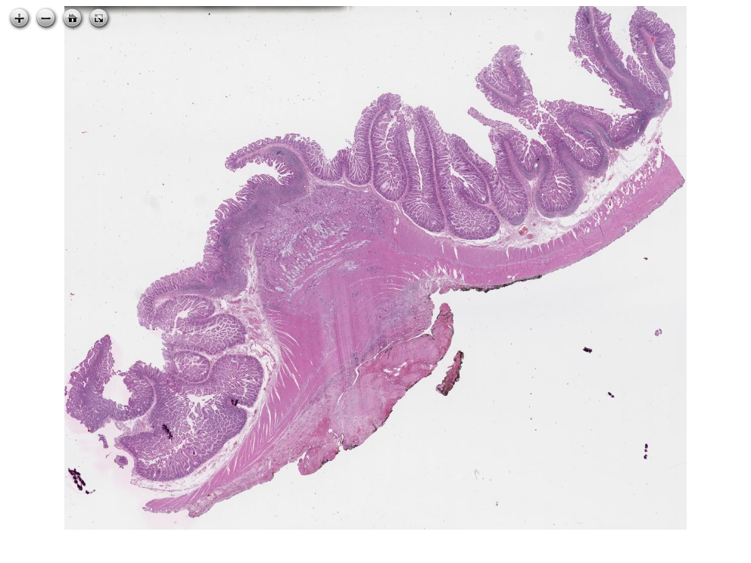](https://images.patolojiatlasi.com/tumor-spread/HE-small-intestine.html) [Click for Full Screen WSI](https://images.patolojiatlasi.com/tumor-spread/HE-small-intestine.html)

# 25. Venous invasion

**Venous invasion**

[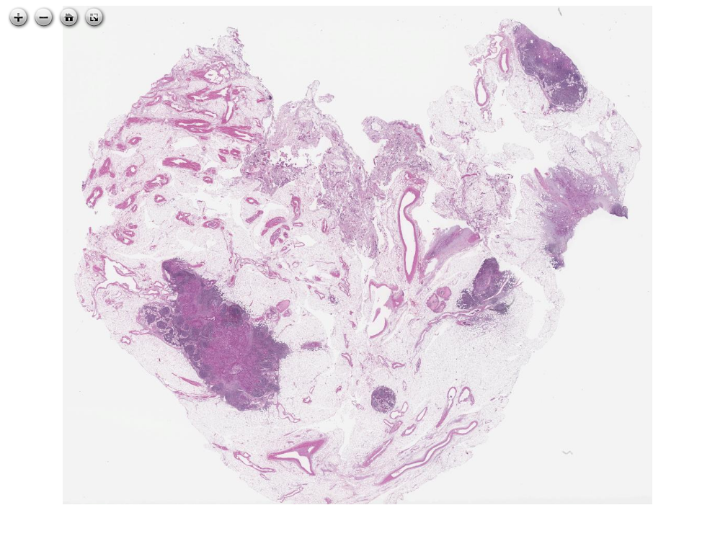](https://images.patolojiatlasi.com/venous-invasion/HE.html) [Click for Full Screen WSI](https://images.patolojiatlasi.com/venous-invasion/HE.html)

# 26. Extramural Venous Invasion in Adenocarcinoma

**Extramural Venous Invasion in Adenocarcinoma**

[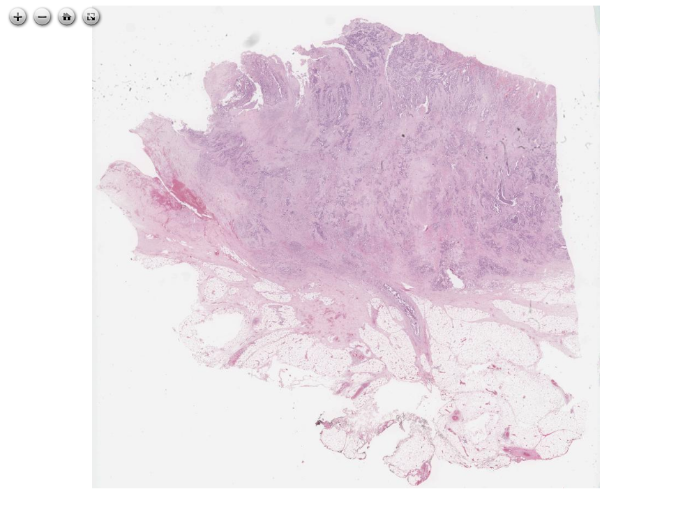](https://images.patolojiatlasi.com/extramuralvenousinvasion/HE.html) [Click for Full Screen WSI](https://images.patolojiatlasi.com/extramuralvenousinvasion/HE.html)

**extramural venous invasion**

[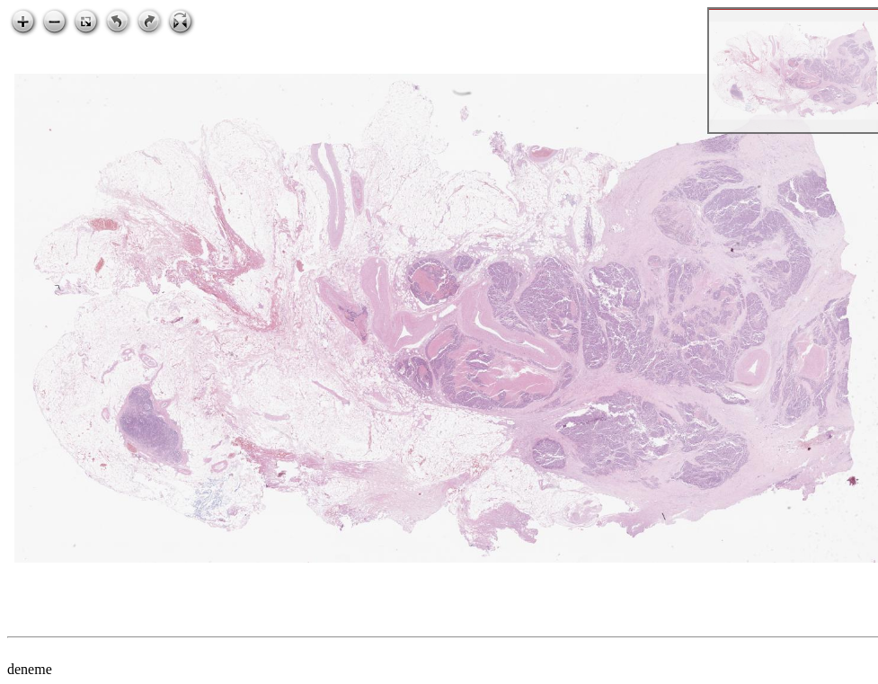](https://images.patolojiatlasi.com/extramural-venous-invasion/HE.html) [Click for Full Screen WSI](https://images.patolojiatlasi.com/extramural-venous-invasion/HE.html)

# 27. Hodgkin Lymphoma

**Hodgkin Lymphoma**

[](https://images.patolojiatlasi.com/template/HE.html) [Click for Full Screen WSI](https://images.patolojiatlasi.com/hodgkin/HE.html)

# 28. Gastrointestinal System

# 29. Esophagus

## 29.1 Granular Cell Tumor in Esophagus

**Granular Cell Tumor in Esophagus**

[](https://images.patolojiatlasi.com/template/HE.html) [Click for Full Screen WSI](https://images.patolojiatlasi.com/granular-cell-tumor/HE.html)

# 30. Pathology of Stomach

## 30.1 Gastritis Cystica Profunda

**Gastritis Cystica Profunda**

[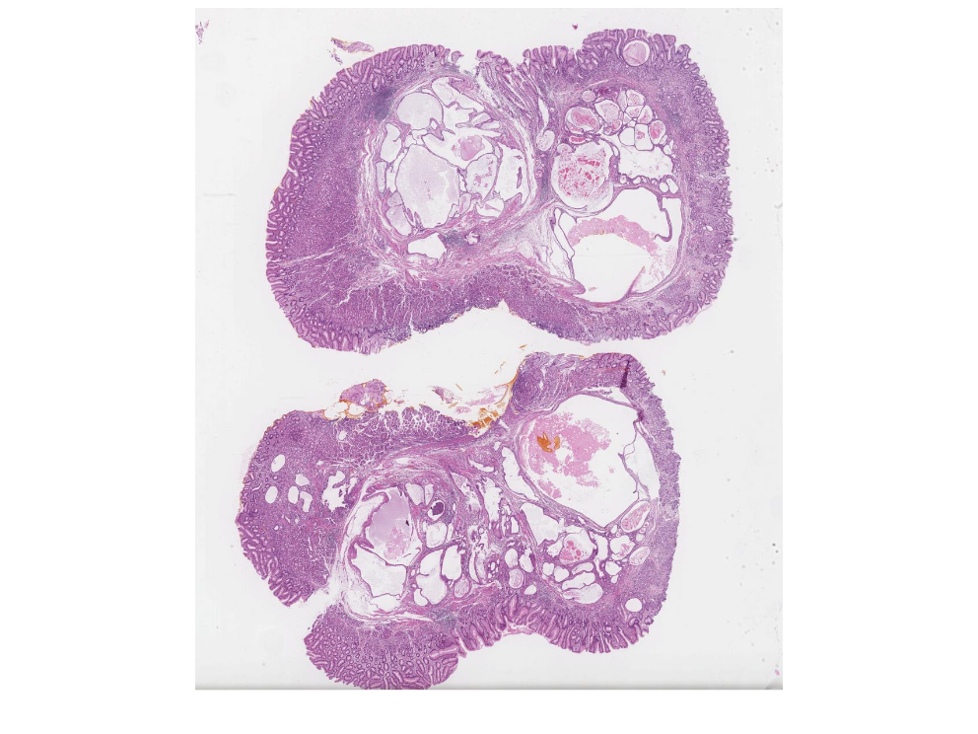](https://images.patolojiatlasi.com/gastritis-cystica-profunda/HE.html) [Click for Full Screen WSI](https://images.patolojiatlasi.com/gastritis-cystica-profunda/HE.html)

# 31. lymphocytic-gastritis

**lymphocytic-gastritis for pathology atlas repositories**

## 31.1 lymphocytic gastritis

**lymphocytic gastritis**

[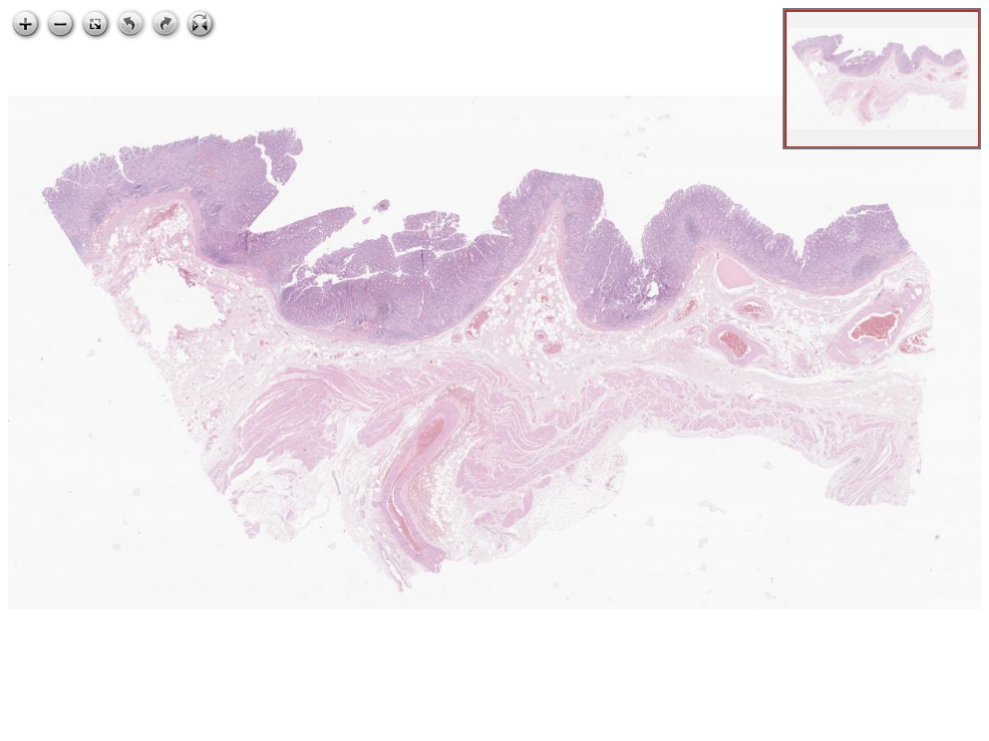](https://images.patolojiatlasi.com/lymphocytic-gastritis/HE.html) [Click for Full Screen WSI](https://images.patolojiatlasi.com/lymphocytic-gastritis/HE.html)

# 32. Duodenum

## 32.1 Celiac Disease

**Celiac Disease**

[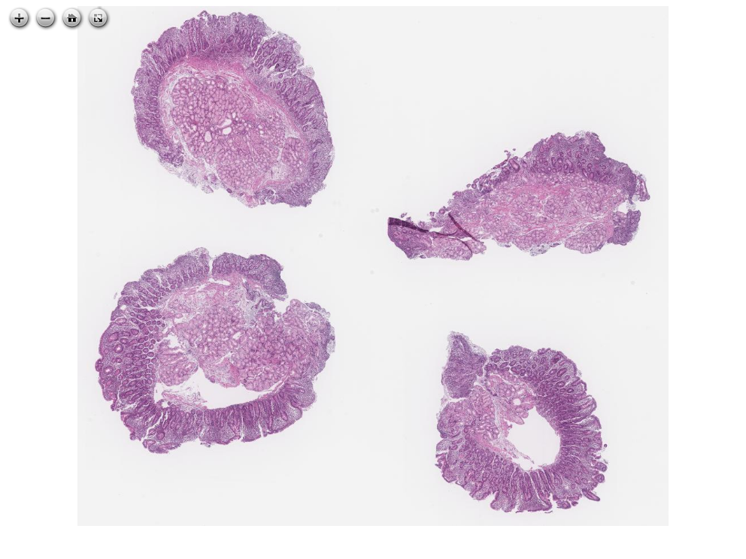](https://images.patolojiatlasi.com/celiac-disease/HE.html) [Click for Full Screen WSI](https://images.patolojiatlasi.com/celiac-disease/HE.html)

# 33. Kolon Patolojisi

## 33.1 Ischemic Colitis

**Ischemic Colitis**

[](https://images.patolojiatlasi.com/template/HE.html) [Click for Full Screen WSI](https://images.patolojiatlasi.com/ischemic-colitis/HE.html)

## 33.2 Benign Tümörler

### 33.2.1 Tübüler Adenom

#### Sesil Polip, Flat (Düz) Tübüler Adenom

[](https://images.patolojiatlasi.com/tubularadenoma-flat/HE.html) [Tam Ekran Görmek İçin Resmi Tıklayın](https://images.patolojiatlasi.com/tubularadenoma-flat/HE.html)

[](https://images.patolojiatlasi.com/tubularadenoma-flat/HE2.html) [Tam Ekran Görmek İçin Resmi Tıklayın](https://images.patolojiatlasi.com/tubularadenoma-flat/HE2.html)

#### Saplı Polip

Macroscopy

[tubular adenoma with a stalk macroscopy](https://images.patolojiatlasi.com/tubularadenoma/tubular-adenoma-with-stalk-macroscopy.jpg)

|  |
| --- |
| saplı polip |

Microscopy

[tubular adenoma with a stalk](https://images.patolojiatlasi.com/tubularadenoma/tubular-adenoma-with-stalk.jpeg)

### 33.2.2 Hiperplastik Polip

Mikroskopi

[](https://images.patolojiatlasi.com/template/HE.html) [Tam Ekran Görmek İçin Resmi Tıklayın](https://images.patolojiatlasi.com/hyperplasticpolyp/case1.html)

### 33.2.3 Hamartomatöz Polip

[](https://images.patolojiatlasi.com/template/HE.html) [Tam Ekran Görmek İçin Resmi Tıklayın](https://images.patolojiatlasi.com/hamartomatouspolyp/HE.html)

#### Schwann Cell Hamartoma in a Colon Polyp

[](https://images.patolojiatlasi.com/template/HE.html) [Tam Ekran Görmek İçin Resmi Tıklayın](https://images.patolojiatlasi.com/schwanncellhamartoma/HE.html)

# 34. Colon submucosal lipoma

**Colon submucosal lipoma**

[](https://images.patolojiatlasi.com/template/HE.html) [Click for Full Screen WSI](https://images.patolojiatlasi.com/colon-submucosal-lipoma/HE.html)

# 35. Mucinous adenocarcinoma of colon arising from tubulovillus adenoma

**Mucinous adenocarcinoma of colon arising from tubulovillus adenoma**

[](https://images.patolojiatlasi.com/template/HE.html) [Click for Full Screen WSI](https://images.patolojiatlasi.com/mucinous-adenocarcinoma-colon/HE.html)

# 36. Colon Adenocarcinoma

**Colon Adenocarcinoma**

[](https://images.patolojiatlasi.com/template/HE.html) [Click for Full Screen WSI](https://images.patolojiatlasi.com/colon-adenocarcinoma/HE.html)

**Colon Adenocarcinoma**

[](https://images.patolojiatlasi.com/template/HE.html) [Click for Full Screen WSI](https://images.patolojiatlasi.com/colon-adenocarcinoma/HE2.html)

**Colon Adenocarcinoma pT4a**

[](https://images.patolojiatlasi.com/template/HE.html) [Click for Full Screen WSI](https://images.patolojiatlasi.com/colon-adenocarcinoma/HE3.html)

# 37. Karaciğer Tümörleri

## 37.1 Hepatoselüler Karsinom

[](https://images.patolojiatlasi.com/template/HE.html) [Tam Ekran Görmek İçin Resmi Tıklayın](https://images.patolojiatlasi.com/hepatocellularcarcinoma/HCC/viewer_z0.html)

## 37.2 Hepatocellular carcinoma, fibrolamellar

**Hepatocellular carcinoma, fibrolamellar**

[](https://images.patolojiatlasi.com/template/HE.html) [Click for Full Screen WSI](https://images.patolojiatlasi.com/fibrolamellar-hepatocellular-carcinoma/HE1.html)

[](https://images.patolojiatlasi.com/template/HE.html) [Click for Full Screen WSI](https://images.patolojiatlasi.com/fibrolamellar-hepatocellular-carcinoma/HE4.html)

# 38. Benign Liver Tumors

## 38.1 Liver Hemangioma

**Liver Hemangioma**

[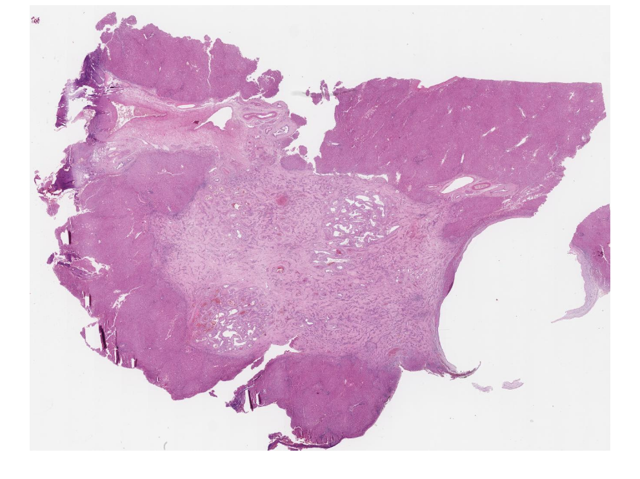](https://images.patolojiatlasi.com/liver-hemangioma/HE.html) [Click for Full Screen WSI](https://images.patolojiatlasi.com/liver-hemangioma/HE.html)

# 39. Tumors of the Pancreas

## 39.1 pancreas, undifferentiated carcinoma with osteoclast-like giant cells, arising within a mucinous adenocarcinoma

**pancreas, undifferentiated carcinoma with osteoclast-like giant cells, arising within a mucinous adenocarcinoma**

[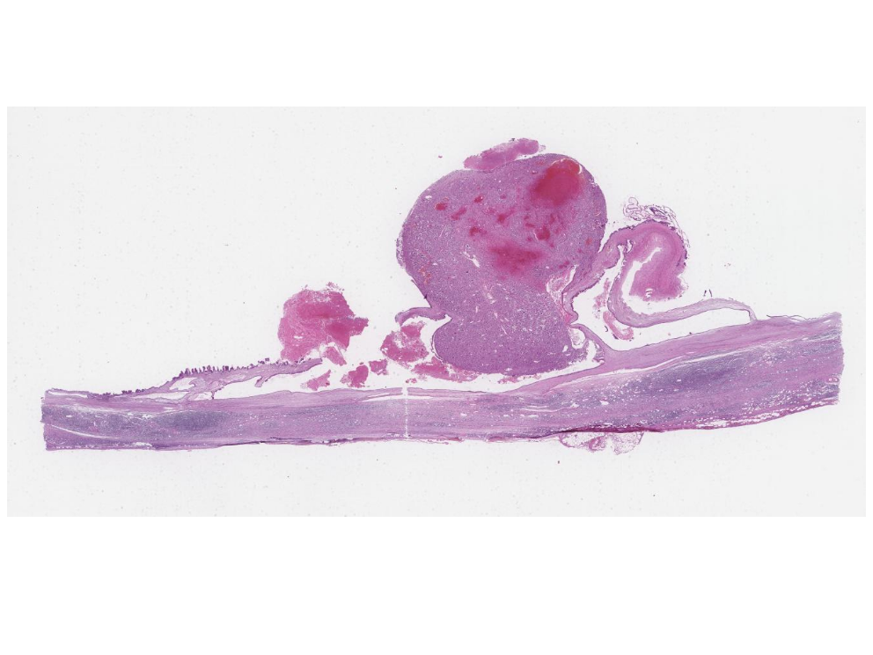](https://images.patolojiatlasi.com/pancreas-undifferentiated-osteoclast/HE.html) [Click for Full Screen WSI](https://images.patolojiatlasi.com/pancreas-undifferentiated-osteoclast/HE.html)

# 40. Gallbladder

## 40.1 Gallbladder Adenomyoma

**Gallbladder Adenomyoma**

[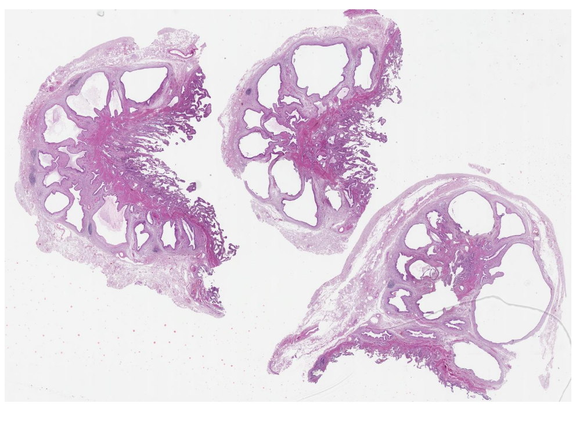](https://images.patolojiatlasi.com/gallbladder-adenomyoma/HE.html) [Click for Full Screen WSI](https://images.patolojiatlasi.com/gallbladder-adenomyoma/HE.html)

## 40.2 ischemia in gangrenous cholecystitis

**ischemia in gangrenous cholecystitis**

[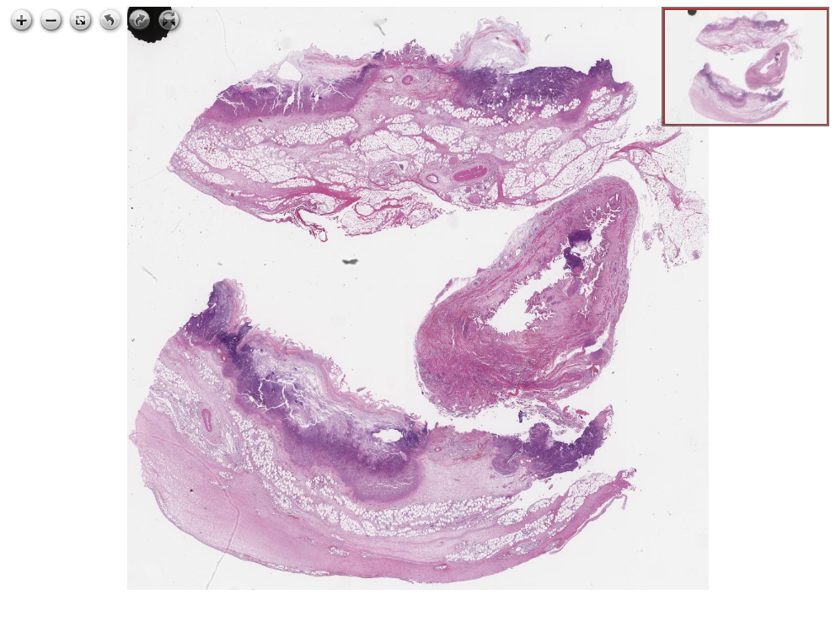](https://images.patolojiatlasi.com/ischemia-gangrenous-cholecystitis/HE.html) [Click for Full Screen WSI](https://images.patolojiatlasi.com/ischemia-gangrenous-cholecystitis/HE.html)

# 41. Ampulla of Vater

## 41.1 Adenocarcinoma of Ampulla of Vater

**Adenocarcinoma of Ampulla of Vater**

[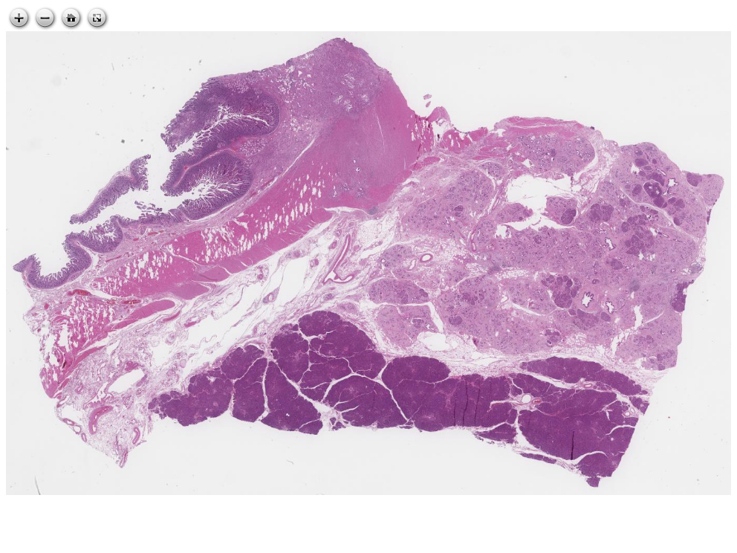](https://images.patolojiatlasi.com/ampullary-adenocarcinoma/HE.html) [Click for Full Screen WSI](https://images.patolojiatlasi.com/ampullary-adenocarcinoma/HE.html)

# 42. Neuroendocrine Tumors

## 42.1 Neuroendocrine Tumor Cytology Giemsa

**Neuroendocrine Tumor Cytology Giemsa**

[](https://images.patolojiatlasi.com/template/HE.html) [Click for Full Screen WSI](https://images.patolojiatlasi.com/neuroendocrine-cytology/giemsa.html)

# 43. Mesothelium

## 43.1 Abdominal mesothelioma

**Abdominal mesothelioma**

[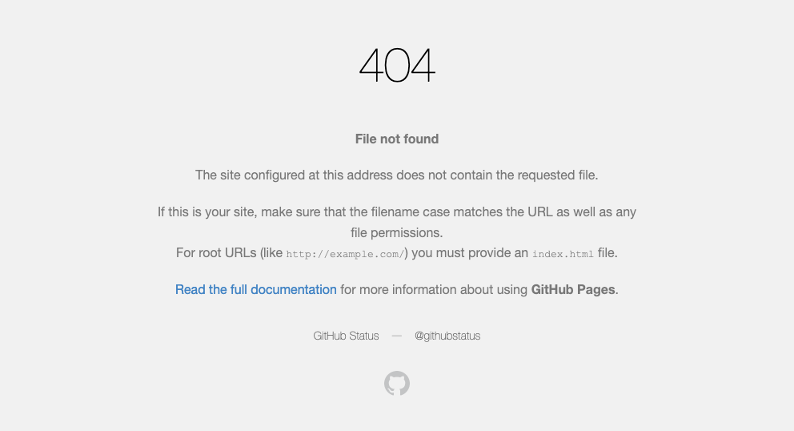](https://images.patolojiatlasi.com/abdominal-mezotelyoma/HE.html) [Click for Full Screen WSI](https://images.patolojiatlasi.com/abdominal-mesothelioma/HE.html)

# 44.

# 45. Genital Sistem Patolojisi

# 46. Cervix

## 46.1 Cervix Squamous Cell Carcinoma

**Cervix Squamous Cell Carcinoma**

[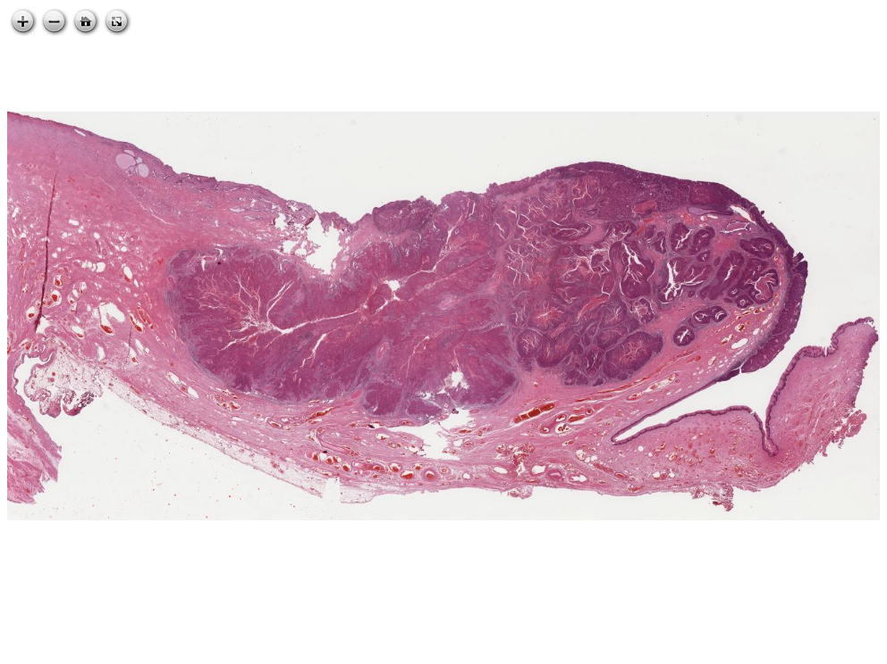](https://images.patolojiatlasi.com/cervix-SCC/HE.html) [Click for Full Screen WSI](https://images.patolojiatlasi.com/cervix-SCC/HE.html)

# 47. Endometrial Polyp

**Endometrial Polyp**

[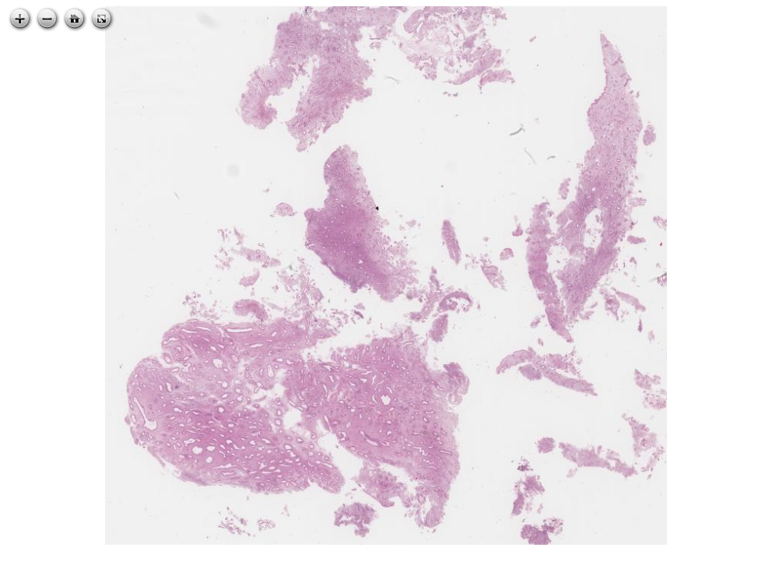](https://images.patolojiatlasi.com/endometrial-polyp/HE.html) [Click for Full Screen WSI](https://images.patolojiatlasi.com/endometrial-polyp/HE.html)

# 48. Endometriosis

**Endometriosis in small intestine wall, causing loop obstruction**

[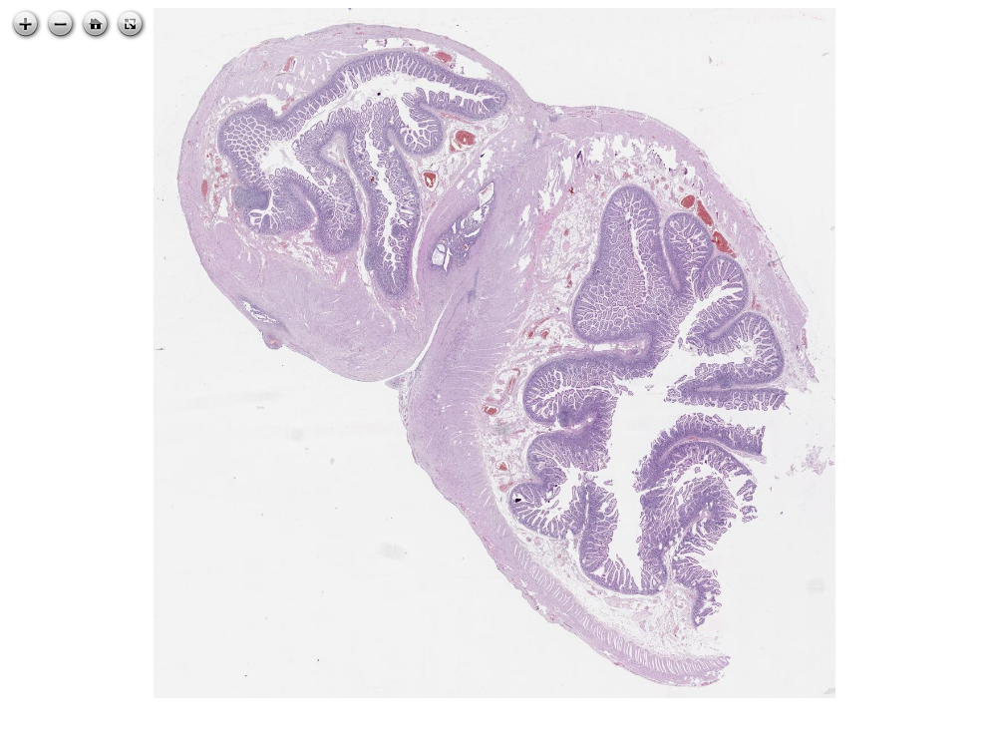](https://images.patolojiatlasi.com/endometriosis/HE.html) [Click for Full Screen WSI](https://images.patolojiatlasi.com/endometriosis/HE.html)

# 49. Pathology of the Urinary System

# 50. Böbrek Tümörleri

## 50.1 Onkositom

[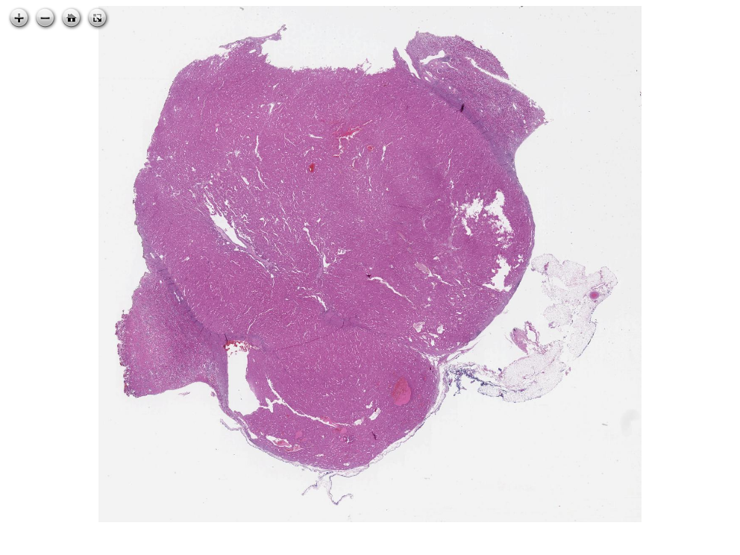](https://images.patolojiatlasi.com/kidneyoncocytoma/HE.html) [Tam Ekran Görmek İçin Resmi Tıklayın](https://images.patolojiatlasi.com/kidneyoncocytoma/HE.html)

# 51. Prostate

## 51.1 benign prostate hyperplasia

**benign prostate hyperplasia**

[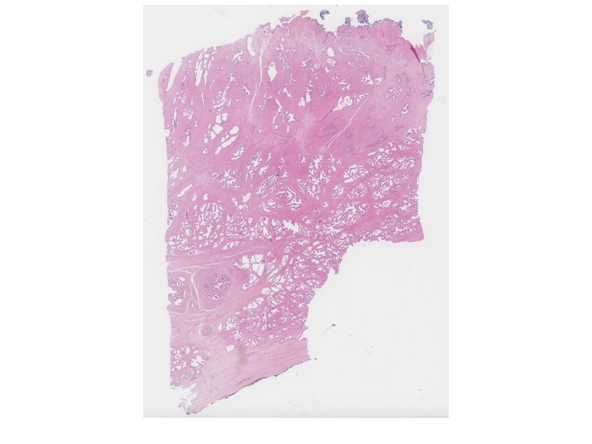](https://images.patolojiatlasi.com/benign-prostate-hyperplasia/HE.html) [Click for Full Screen WSI](https://images.patolojiatlasi.com/benign-prostate-hyperplasia/HE.html)

# 52. Pituitary Adenoma

**Pituitary Adenoma**

[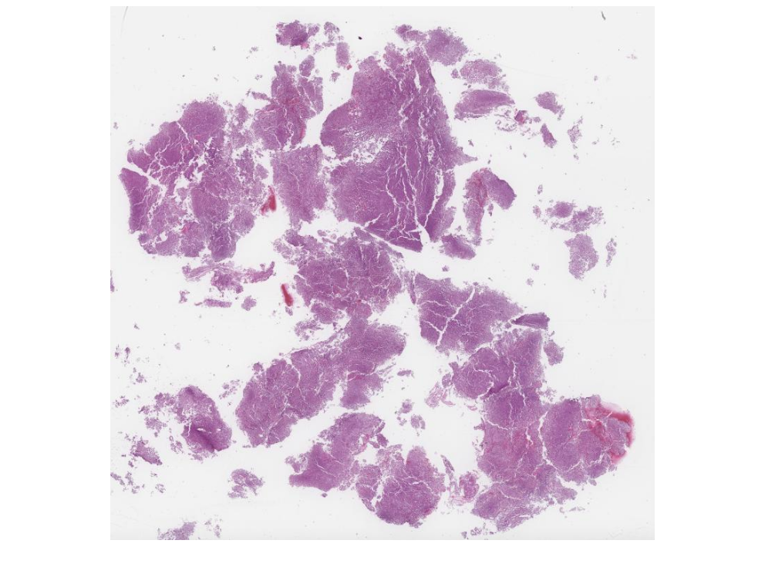](https://images.patolojiatlasi.com/pituitary-adenoma/HE.html) [Click for Full Screen WSI](https://images.patolojiatlasi.com/pituitary-adenoma/HE.html)

# Meme Patolojisi

# Breast Pathology

See extended list of Breast Pathology cases here <https://images.patolojiatlasi.com/breast/>

# 53. Nasopharynx

## 53.1 Nasopharyngeal carcinoma, nonkeratinizing squamous cell carcinoma

** Nasopharyngeal carcinoma, nonkeratinizing squamous cell carcinoma**

[](https://images.patolojiatlasi.com/nasopharynx-nonkeratinizing-scc/HE.html) [Click for Full Screen WSI](https://images.patolojiatlasi.com/nasopharynx-nonkeratinizing-scc/HE.html)

[](https://images.patolojiatlasi.com/nasopharynx-nonkeratinizing-scc/HE.html) [Click for Full Screen WSI](https://images.patolojiatlasi.com/nasopharynx-nonkeratinizing-scc/panCK.html)

[](https://images.patolojiatlasi.com/nasopharynx-nonkeratinizing-scc/HE.html) [Click for Full Screen WSI](https://images.patolojiatlasi.com/nasopharynx-nonkeratinizing-scc/p63.html)

[](https://images.patolojiatlasi.com/nasopharynx-nonkeratinizing-scc/HE.html) [Click for Full Screen WSI](https://images.patolojiatlasi.com/nasopharynx-nonkeratinizing-scc/EBER.html)

# 54. Kulak

### 54.0.1 Kolesteatom

[](https://images.patolojiatlasi.com/template/HE.html) [Tam Ekran Görmek İçin Resmi Tıklayın](https://images.patolojiatlasi.com/cholesteatoma/cholesteatoma.html)

# 55. Tumors of Salivary Gland

## 55.1 mammary analogue secretory carcinoma of salivary gland

** mammary analogue secretory carcinoma of salivary gland**

[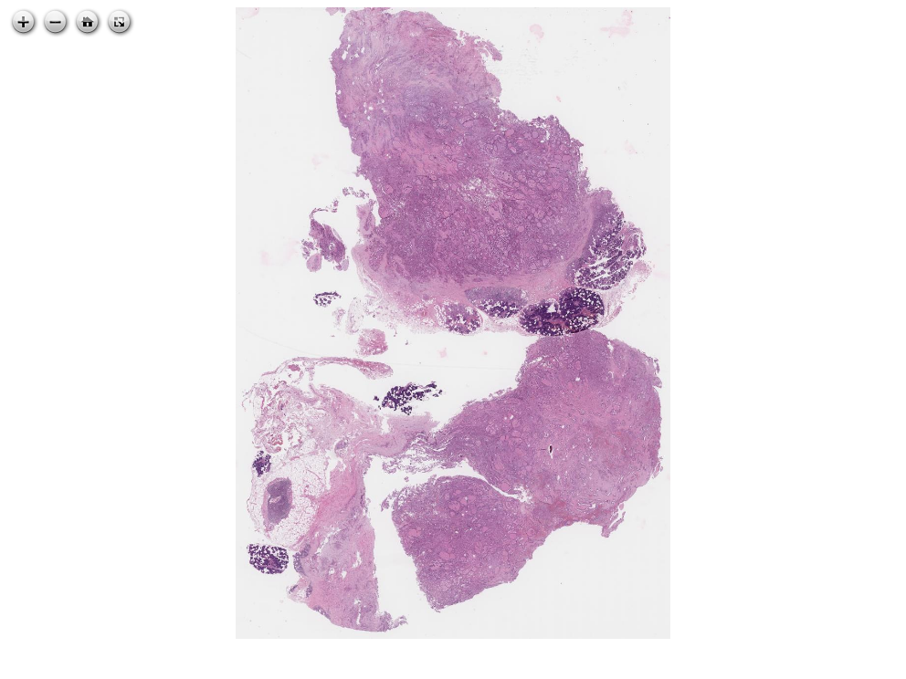](https://images.patolojiatlasi.com/mammary-analogue-secretory-carcinoma/HE1.html) [Click for Full Screen WSI](https://images.patolojiatlasi.com/mammary-analogue-secretory-carcinoma/HE1.html)

# 56. High Grade Glioma Squash Slide

**High Grade Glioma Squash Slide**

[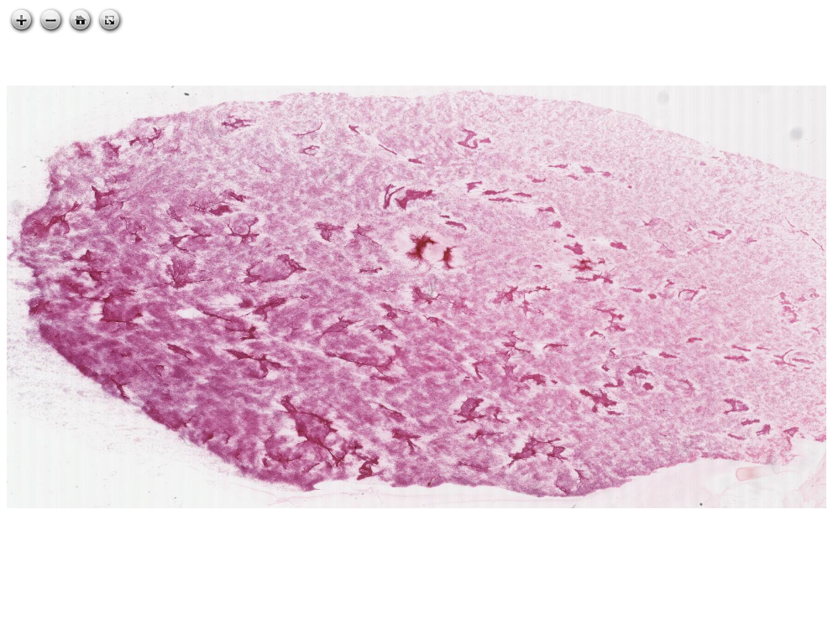](https://images.patolojiatlasi.com/high-grade-glioma-squash/HE.html) [Click for Full Screen WSI](https://images.patolojiatlasi.com/high-grade-glioma-squash/HE.html)

# 57. Brain Invasive Meningioma

**Brain Invasive Meningioma**

[](https://images.patolojiatlasi.com/template/HE.html) [Click for Full Screen WSI](https://images.patolojiatlasi.com/brain-invasive-meningioma/HE.html)

# 58. Meningioma Bone Infiltration

**Meningioma Bone Infiltration**

[](https://images.patolojiatlasi.com/template/HE.html) [Click for Full Screen WSI](https://images.patolojiatlasi.com/meningioma-bone-infiltration/HE.html)

# 59. Central Nervous System Vascular Lesions

## 59.1 Brain arteriovenous malformation

**brain arteriovenous malformation**

[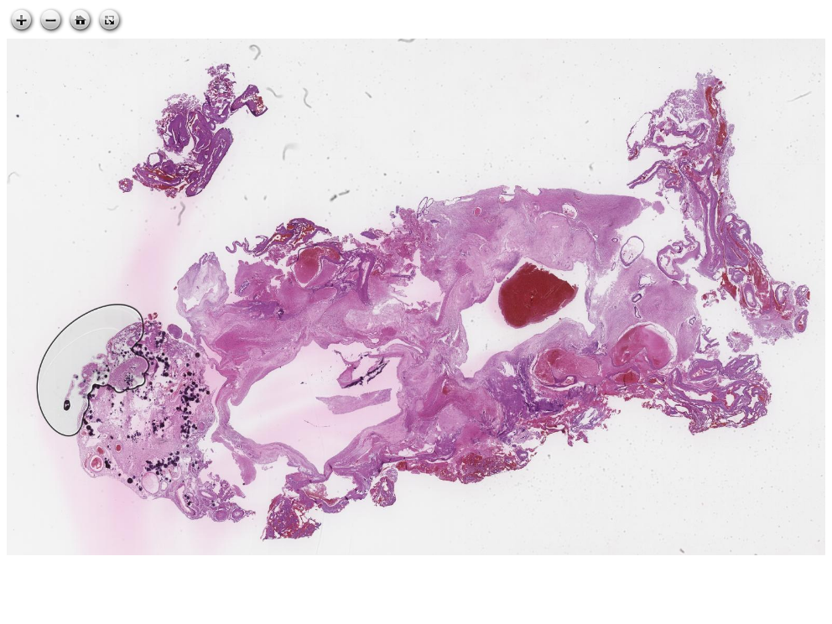](https://images.patolojiatlasi.com/brain-arteriovenous-malformation/HE.html) [Click for Full Screen WSI](https://images.patolojiatlasi.com/brain-arteriovenous-malformation/HE.html)

# 60. Kemik Tümörleri

## 60.1 Benign Kemik Tümörleri

### 60.1.1 Ekzostoz (Osteokondrom)

[](https://images.patolojiatlasi.com/template/HE.html) [Tam Ekran Görmek İçin Resmi Tıklayın](https://images.patolojiatlasi.com/exostosis/oc.html)

[](https://images.patolojiatlasi.com/template/HE.html) [Tam Ekran Görmek İçin Resmi Tıklayın](https://images.patolojiatlasi.com/exostosis/oc001.html)

[](https://images.patolojiatlasi.com/template/HE.html) [Tam Ekran Görmek İçin Resmi Tıklayın](https://images.patolojiatlasi.com/exostosis/oc002.html)

# 61. Adipose Tissue

## 61.1 Myxoid Liposarcoma

**Myxoid Liposarcoma**

[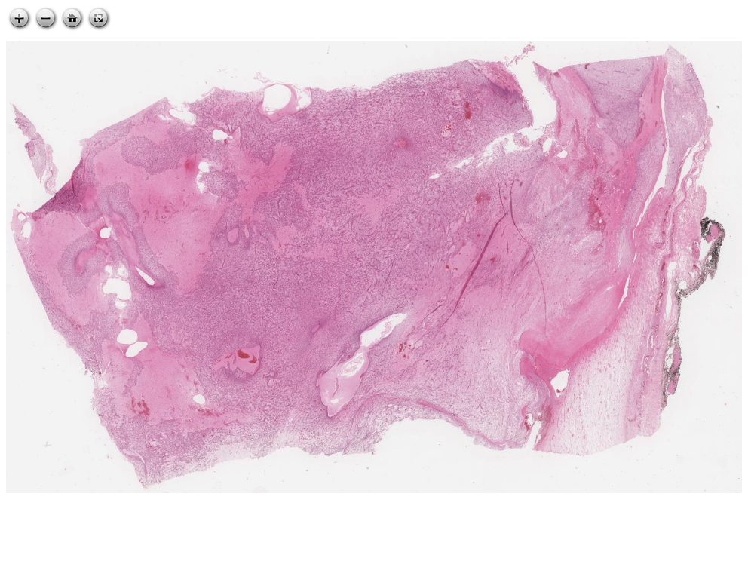](https://images.patolojiatlasi.com/myxoidliposarcoma/HE.html) [Click for Full Screen WSI](https://images.patolojiatlasi.com/myxoidliposarcoma/HE.html)

# 62. Placenta

## 62.1 Chorioamnionitis

[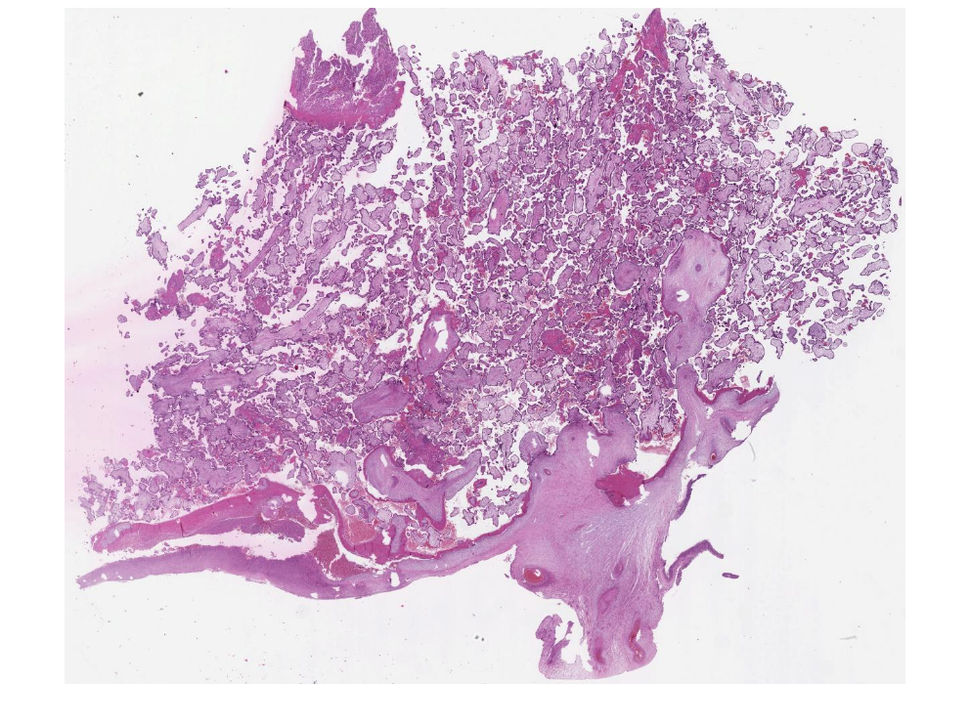](https://images.patolojiatlasi.com/chorioamnionitis/HE.html) [Click for Full Screen WSI](https://images.patolojiatlasi.com/chorioamnionitis/HE.html)

# 63. Pages Containing Whole Slide Images for Pathology Education

## 63.1 Rosai Collection

<https://www.rosaicollection.org/>

## 63.2 Atlas of Medical Foreign Bodies

<https://www.flickr.com/photos/158161000@N04>

## 63.3 Patoloji Dernekleri Federasyonu Olgu Sayfası

<https://www.turkpath.org.tr/case.list.php>

## 63.4 Dermatopathology Collection

A collection of online dermatopathology resources for residents and fellows. [JAAD Int. 2023 Jan 30;12:12-14.](https://www.jaadinternational.org/article/S2666-3287(23)00015-9/fulltext) doi: 10.1016/j.jdin.2022.12.007. PMID: [37228363](https://pubmed.ncbi.nlm.nih.gov/37228363/); PMCID: PMC10203758. https://www.sciencedirect.com/science/article/pii/S2666328723000159 [@Mukosera2023]

# 64.

**These cases are from the collections of Gulen Bulbul Dogusoy MD.**

# 65. [Hacettepe Case Of the Month (COM)](https://hacettepepathology.com/)

**These cases are from the collections of Kemal Kosemehmetoglu MD and Arzu Saglam MD.**

## 65.1 Case-1

* [Case-1](https://www.youtube.com/watch?v=nfFtViUXHqU&ab_channel=KemalKosemehmetoglu)

<https://www.youtube.com/embed/nfFtViUXHqU>

**hacettepe-com-case-1**

Show the Diagnosis

Intradermal Nodular Fasciitis

[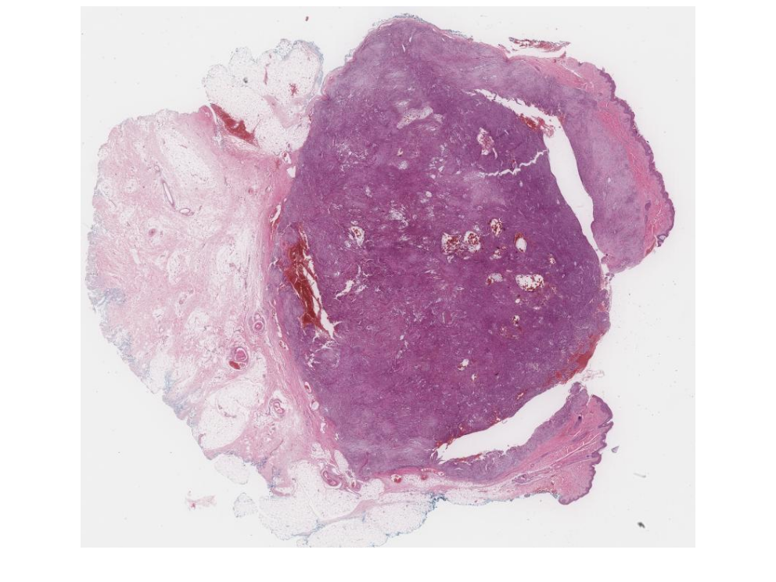](https://images.patolojiatlasi.com/hacettepe-com-case-1/HE.html) [Click for Full Screen WSI](https://images.patolojiatlasi.com/hacettepe-com-case-1/HE.html)

## 65.2 Case-2

* [case 2](https://www.youtube.com/watch?v=xHQihI19L5g&ab_channel=KemalKosemehmetoglu)

<https://www.youtube.com/embed/xHQihI19L5g>

**hacettepe-com-case-2**

Show the Diagnosis

Sarcoma with INI1 loss, previously diagnosed as yolk sac tumor

[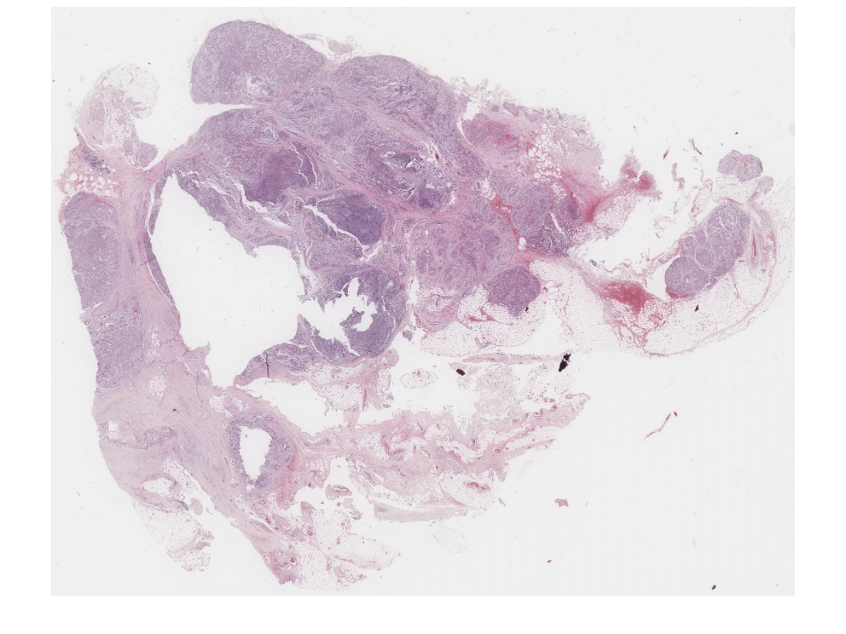](https://images.patolojiatlasi.com/hacettepe-com-case-2/HE.html) [Click for Full Screen WSI](https://images.patolojiatlasi.com/hacettepe-com-case-2/HE.html)

## 65.3 Case-3

* [case 3](https://www.youtube.com/watch?v=JGDsmznBqZM&ab_channel=KemalKosemehmetoglu)

<https://www.youtube.com/embed/JGDsmznBqZM>

[case 3, scopy](https://www.youtube.com/watch?v=yKnEyGE4oD4&ab_channel=KemalKosemehmetoglu)

<https://www.youtube.com/embed/yKnEyGE4oD4>

**hacettepe-com-case-3**

Show the Diagnosis

Rhabdomyosarcoma of Bladder

[](https://images.patolojiatlasi.com/hacettepe-com-case-3/HE.html) [Click for Full Screen WSI](https://images.patolojiatlasi.com/hacettepe-com-case-3/HE.html)

## 65.4 Case-4

* [case 4](https://www.youtube.com/watch?v=Akp6H3myCIo&ab_channel=KemalKosemehmetoglu)

<https://www.youtube.com/embed/Akp6H3myCIo>

**hacettepe-com-case-4**

Show the Diagnosis

Liposarcoma, inflammatory variant

[](https://images.patolojiatlasi.com/hacettepe-com-case-4/HE.html) [Click for Full Screen WSI](https://images.patolojiatlasi.com/hacettepe-com-case-4/HE1.html)

[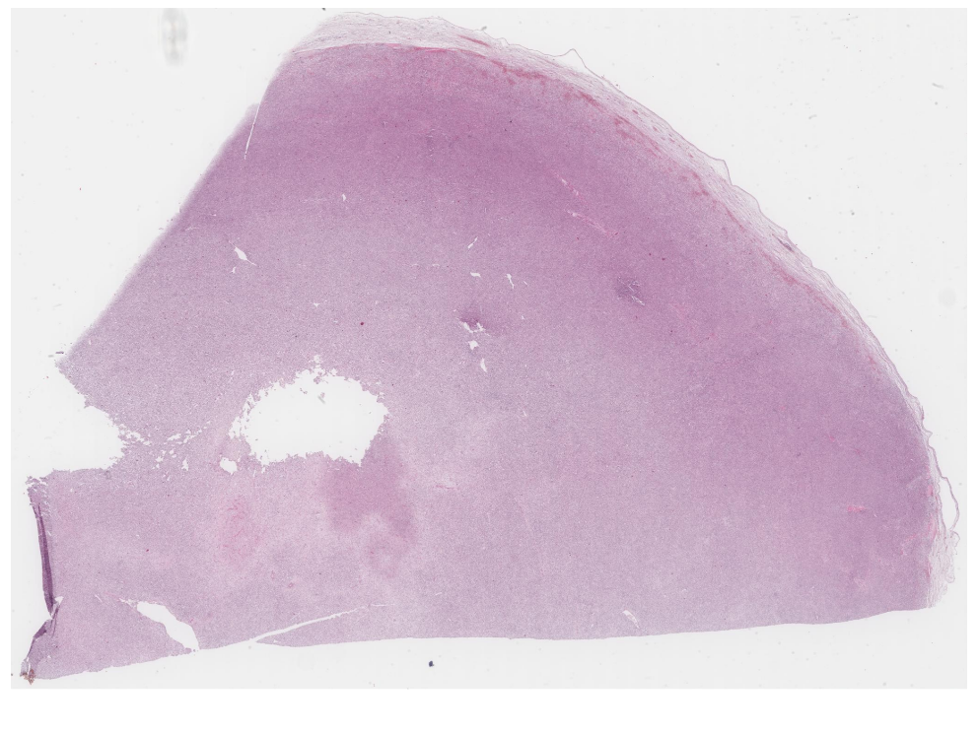](https://images.patolojiatlasi.com/hacettepe-com-case-4/HE2.html) [Click for Full Screen WSI](https://images.patolojiatlasi.com/hacettepe-com-case-4/HE2.html)

## 65.5 Case-5

* [case 5](https://www.youtube.com/watch?v=o13qcP56mqg&ab_channel=KemalKosemehmetoglu)

<https://www.youtube.com/embed/o13qcP56mqg>

[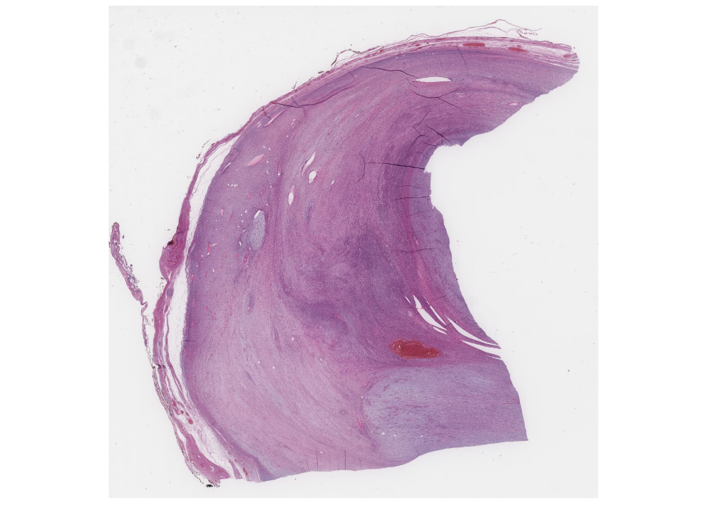](https://images.patolojiatlasi.com/hacettepe-com-case-5/HE.html) [Tam Ekran Görmek İçin Resmi Tıklayın](https://images.patolojiatlasi.com/hacettepe-com-case-5/HE.html)

**hacettepe-com-case-5**

Show the Diagnosis

Malignant peripheral nerve sheath tumor, perineural differantiation

[](https://images.patolojiatlasi.com/hacettepe-com-case-5/HE.html) [Click for Full Screen WSI](https://images.patolojiatlasi.com/hacettepe-com-case-5/HE.html)

## 65.6 Case-6

* [case 6](https://www.youtube.com/watch?v=ipjRs0h1PnY&ab_channel=KemalKosemehmetoglu)

<https://www.youtube.com/embed/ipjRs0h1PnY>

[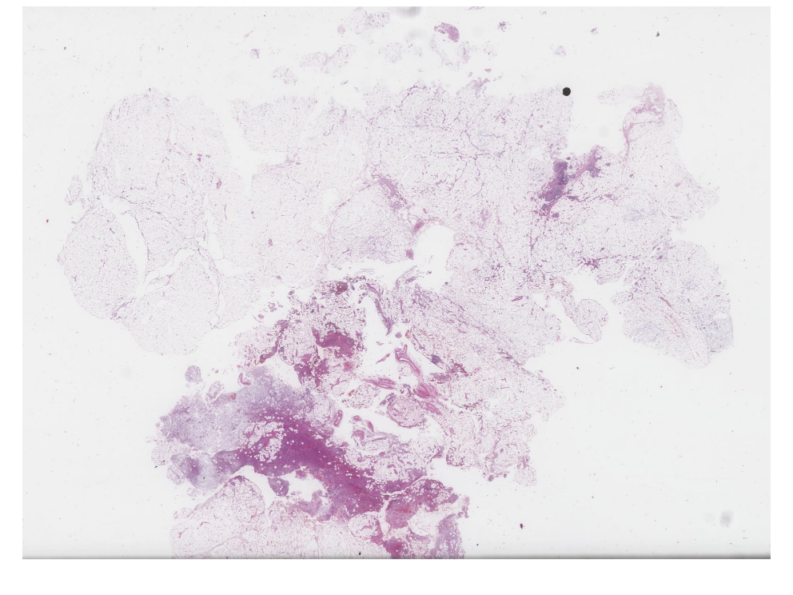](https://images.patolojiatlasi.com/hacettepe-com-case-6/HE.html) [Tam Ekran Görmek İçin Resmi Tıklayın](https://images.patolojiatlasi.com/hacettepe-com-case-6/HE.html)

**hacettepe-com-case-6**

Show the Diagnosis

Hybrid hemosiderotic fibrolipomatous tumor - myxoinflammatory

[](https://images.patolojiatlasi.com/hacettepe-com-case-6/HE.html) [Click for Full Screen WSI](https://images.patolojiatlasi.com/hacettepe-com-case-6/HE.html)

## 65.7 Case-7

* [case 7](https://www.youtube.com/watch?v=FU-Fv7kQPdE&ab_channel=KemalKosemehmetoglu)

<https://www.youtube.com/embed/FU-Fv7kQPdE>

[](https://images.patolojiatlasi.com/hacettepe-com-case-7/HE.html) [Tam Ekran Görmek İçin Resmi Tıklayın](https://images.patolojiatlasi.com/hacettepe-com-case-7/HE.html)

[](https://images.patolojiatlasi.com/hacettepe-com-case-7/HE.html) [Click for Full Screen WSI](https://images.patolojiatlasi.com/hacettepe-com-case-7/HE.html)

## 65.8 Case-8

* [case 8](https://www.youtube.com/watch?v=c8pDBHRO7t8&ab_channel=KemalKosemehmetoglu)

<https://www.youtube.com/embed/c8pDBHRO7t8>

## 65.9 Case-9

* [case 9](https://www.youtube.com/watch?v=9OxpsDNCHWk&ab_channel=KemalKosemehmetoglu)

<https://www.youtube.com/embed/9OxpsDNCHWk>

**hacettepe-com-case-9**

Show the Diagnosis

angiomatoid fibrous histiocytoma

[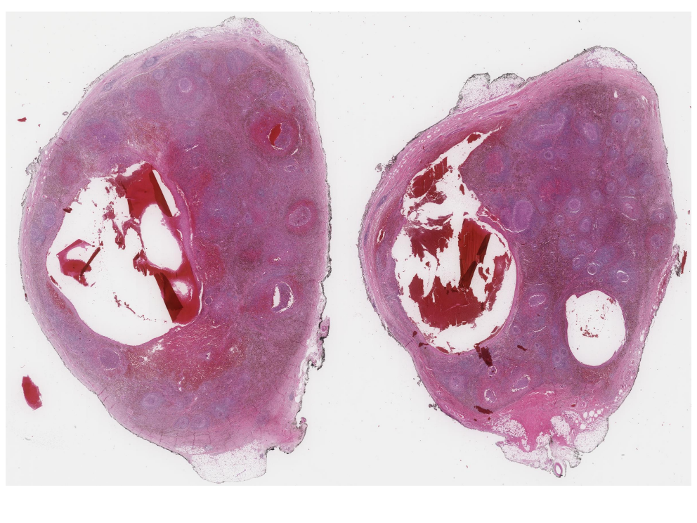](https://images.patolojiatlasi.com/hacettepe-com-case-9/HE.html) [Click for Full Screen WSI](https://images.patolojiatlasi.com/hacettepe-com-case-9/HE.html)

## 65.10 Case-10

* [case 10](https://www.youtube.com/watch?v=0vNcCaTYstU&ab_channel=KemalKosemehmetoglu)

<https://www.youtube.com/embed/0vNcCaTYstU>

**hacettepe-com-case-10**

Show the Diagnosis

myxoinflammatory fibroblastic sarcoma, psoas

[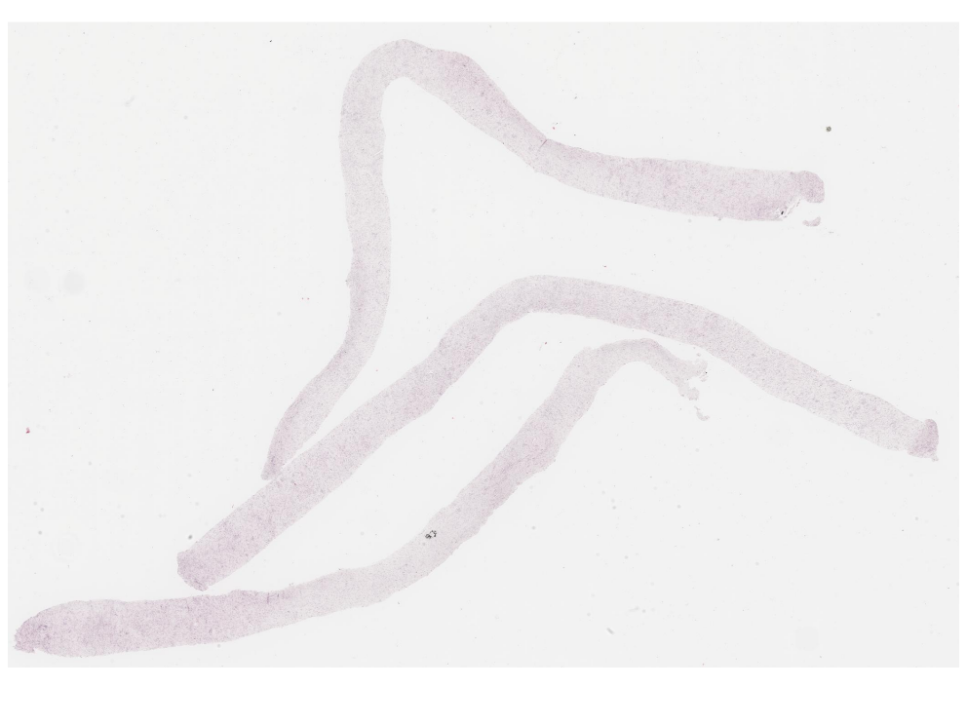](https://images.patolojiatlasi.com/hacettepe-com-case-10/HE.html) [Click for Full Screen WSI](https://images.patolojiatlasi.com/hacettepe-com-case-10/HE.html)

## 65.11 Case-11

* [case 11](https://www.youtube.com/watch?v=A5XO1Kp11Zk&ab_channel=KemalKosemehmetoglu)

<https://www.youtube.com/embed/A5XO1Kp11Zk>

[](https://images.patolojiatlasi.com/hacettepe-com-case-1/HE.html) [Tam Ekran Görmek İçin Resmi Tıklayın](https://images.patolojiatlasi.com/hacettepe-com-case-11/HE.html)

[](https://images.patolojiatlasi.com/hacettepe-com-case-1/HE.html) [Click for Full Screen WSI](https://images.patolojiatlasi.com/hacettepe-com-case-11/HE.html)

## 65.12 Case-12

* [case 12](https://www.youtube.com/watch?v=2TwT4sE9XmM&ab_channel=KemalKosemehmetoglu)

<https://www.youtube.com/embed/2TwT4sE9XmM>

[](https://images.patolojiatlasi.com/hacettepe-com-case-1/HE.html) [Tam Ekran Görmek İçin Resmi Tıklayın](https://images.patolojiatlasi.com/hacettepe-com-case-12/HE.html)

**hacettepe-com-case-12**

Show the Diagnosis

myelolipoma, periprostatic

[](https://images.patolojiatlasi.com/hacettepe-com-case-1/HE.html) [Click for Full Screen WSI](https://images.patolojiatlasi.com/hacettepe-com-case-12/HE.html)

## 65.13 Case-13

* [case 13](https://www.youtube.com/watch?v=TLRJ0pBrwxA&ab_channel=KemalKosemehmetoglu)

<https://www.youtube.com/embed/TLRJ0pBrwxA>

[](https://images.patolojiatlasi.com/hacettepe-com-case-1/HE.html) [Tam Ekran Görmek İçin Resmi Tıklayın](https://images.patolojiatlasi.com/hacettepe-com-case-13/HE.html)

**hacettepe-com-case-13**

Show the Diagnosis

intranodal pallisading myofibroblastoma

[](https://images.patolojiatlasi.com/hacettepe-com-case-1/HE.html) [Click for Full Screen WSI](https://images.patolojiatlasi.com/hacettepe-com-case-13/HE.html)

## 65.14 Case-14

* [case 14](https://www.youtube.com/watch?v=MVZntjhry6g&ab_channel=KemalKosemehmetoglu)

<https://www.youtube.com/embed/MVZntjhry6g>

[](https://images.patolojiatlasi.com/hacettepe-com-case-1/HE.html) [Tam Ekran Görmek İçin Resmi Tıklayın](https://images.patolojiatlasi.com/hacettepe-com-case-14/HE.html)

**hacettepe-com-case-14**

Show the Diagnosis

DSRCT

[](https://images.patolojiatlasi.com/hacettepe-com-case-1/HE.html) [Click for Full Screen WSI](https://images.patolojiatlasi.com/hacettepe-com-case-14/HE.html)

## 65.15 Case-15

* [case 15](https://www.youtube.com/watch?v=3lmx9hYGcG8&ab_channel=KemalKosemehmetoglu)

<https://www.youtube.com/embed/3lmx9hYGcG8>

[](https://images.patolojiatlasi.com/hacettepe-com-case-1/HE.html) [Tam Ekran Görmek İçin Resmi Tıklayın](https://images.patolojiatlasi.com/hacettepe-com-case-/HE.html)

[](https://images.patolojiatlasi.com/hacettepe-com-case-1/HE.html) [Click for Full Screen WSI](https://images.patolojiatlasi.com/hacettepe-com-case-/HE.html)

## 65.16 Case-16

* [case 16](https://www.youtube.com/watch?v=Tkempcd59I0&ab_channel=KemalKosemehmetoglu)

<https://www.youtube.com/embed/Tkempcd59I0>

[](https://images.patolojiatlasi.com/hacettepe-com-case-1/HE.html) [Tam Ekran Görmek İçin Resmi Tıklayın](https://images.patolojiatlasi.com/hacettepe-com-case-/HE.html)

[](https://images.patolojiatlasi.com/hacettepe-com-case-1/HE.html) [Click for Full Screen WSI](https://images.patolojiatlasi.com/hacettepe-com-case-/HE.html)

## 65.17 Case-17

* [case 17](https://www.youtube.com/watch?v=zlewGuN0BBY&ab_channel=KemalKosemehmetoglu)

<https://www.youtube.com/embed/zlewGuN0BBY>

[](https://images.patolojiatlasi.com/hacettepe-com-case-1/HE.html) [Tam Ekran Görmek İçin Resmi Tıklayın](https://images.patolojiatlasi.com/hacettepe-com-case-17/HE1.html)

**hacettepe-com-case-17**

Show the Diagnosis

IMT bladder

[](https://images.patolojiatlasi.com/hacettepe-com-case-1/HE.html) [Click for Full Screen WSI](https://images.patolojiatlasi.com/hacettepe-com-case-17/HE1.html)

## 65.18 Case-18

* [case 18](https://www.youtube.com/watch?v=5c_5A4z6tro&ab_channel=KemalKosemehmetoglu)

<https://www.youtube.com/embed/5c_5A4z6tro>

[](https://images.patolojiatlasi.com/hacettepe-com-case-1/HE.html) [Tam Ekran Görmek İçin Resmi Tıklayın](https://images.patolojiatlasi.com/hacettepe-com-case-18/HE.html)

**hacettepe-com-case-18**

Show the Diagnosis

myxoid LPS, paratesticular

[](https://images.patolojiatlasi.com/hacettepe-com-case-1/HE.html) [Click for Full Screen WSI](https://images.patolojiatlasi.com/hacettepe-com-case-18/HE.html)

## 65.19 Case-19

* [case 19](https://www.youtube.com/watch?v=SaNDCvKzQ6M&ab_channel=KemalKosemehmetoglu)

<https://www.youtube.com/embed/SaNDCvKzQ6M>

[](https://images.patolojiatlasi.com/hacettepe-com-case-1/HE.html) [Tam Ekran Görmek İçin Resmi Tıklayın](https://images.patolojiatlasi.com/hacettepe-com-case-19/HE.html)

**hacettepe-com-case-19**

Show the Diagnosis

clear cell sarcoma

[](https://images.patolojiatlasi.com/hacettepe-com-case-1/HE.html) [Click for Full Screen WSI](https://images.patolojiatlasi.com/hacettepe-com-case-19/HE.html)

## 65.20 Case-20

* [case 20](https://www.youtube.com/watch?v=f8nE-6oR5VI&ab_channel=KemalKosemehmetoglu)

<https://www.youtube.com/embed/f8nE-6oR5VI>

[](https://images.patolojiatlasi.com/hacettepe-com-case-1/HE.html) [Tam Ekran Görmek İçin Resmi Tıklayın](https://images.patolojiatlasi.com/hacettepe-com-case-/HE.html)

[](https://images.patolojiatlasi.com/hacettepe-com-case-1/HE.html) [Click for Full Screen WSI](https://images.patolojiatlasi.com/hacettepe-com-case-/HE.html)

## 65.21 Case-21

* [case 21](https://www.youtube.com/watch?v=Uith4SvB2_Q&ab_channel=KemalKosemehmetoglu)

<https://www.youtube.com/embed/Uith4SvB2_Q>

[](https://images.patolojiatlasi.com/hacettepe-com-case-1/HE.html) [Tam Ekran Görmek İçin Resmi Tıklayın](https://images.patolojiatlasi.com/hacettepe-com-case-21/HE.html)

**hacettepe-com-case-21**

Show the Diagnosis

solitary fibrous tumor

[](https://images.patolojiatlasi.com/hacettepe-com-case-1/HE.html) [Click for Full Screen WSI](https://images.patolojiatlasi.com/hacettepe-com-case-21/HE.html)

## 65.22 Case-22

* [case 22](https://www.youtube.com/watch?v=wo6N0q5EiWc&ab_channel=KemalKosemehmetoglu)

<https://www.youtube.com/embed/wo6N0q5EiWc>

[](https://images.patolojiatlasi.com/hacettepe-com-case-1/HE.html) [Tam Ekran Görmek İçin Resmi Tıklayın](https://images.patolojiatlasi.com/hacettepe-com-case-/HE.html)

[](https://images.patolojiatlasi.com/hacettepe-com-case-1/HE.html) [Click for Full Screen WSI](https://images.patolojiatlasi.com/hacettepe-com-case-/HE.html)

## 65.23 Case-23

* [case 23](https://www.youtube.com/watch?v=2j0ER0ShVR0&ab_channel=KemalKosemehmetoglu)

<https://www.youtube.com/embed/2j0ER0ShVR0>

[](https://images.patolojiatlasi.com/hacettepe-com-case-1/HE.html) [Tam Ekran Görmek İçin Resmi Tıklayın](https://images.patolojiatlasi.com/hacettepe-com-case-23/HE.html)

**hacettepe-com-case-23**

Show the Diagnosis

chromophobe RCC

[](https://images.patolojiatlasi.com/hacettepe-com-case-1/HE.html) [Click for Full Screen WSI](https://images.patolojiatlasi.com/hacettepe-com-case-23/HE.html)

## 65.24 Case-24

* [case 24](https://www.youtube.com/watch?v=-S0_Hr6sNZ8&ab_channel=KemalKosemehmetoglu)

<https://www.youtube.com/embed/-S0_Hr6sNZ8>

[](https://images.patolojiatlasi.com/hacettepe-com-case-1/HE.html) [Tam Ekran Görmek İçin Resmi Tıklayın](https://images.patolojiatlasi.com/hacettepe-com-case-24/HE.html)

**hacettepe-com-case-24**

Show the Diagnosis

neuroendocrine tumor of breast, bx tract seeding

[](https://images.patolojiatlasi.com/hacettepe-com-case-1/HE.html) [Click for Full Screen WSI](https://images.patolojiatlasi.com/hacettepe-com-case-24/HE.html)

## 65.25 Case-25

* [case 25](https://www.youtube.com/watch?v=tcmQKs38A14&ab_channel=KemalKosemehmetoglu)

<https://www.youtube.com/embed/tcmQKs38A14>

[](https://images.patolojiatlasi.com/hacettepe-com-case-1/HE.html) [Tam Ekran Görmek İçin Resmi Tıklayın](https://images.patolojiatlasi.com/hacettepe-com-case-25/HE.html)

**hacettepe-com-case-25**

Show the Diagnosis

schwannoma, intraabdominal

[](https://images.patolojiatlasi.com/hacettepe-com-case-1/HE.html) [Click for Full Screen WSI](https://images.patolojiatlasi.com/hacettepe-com-case-25/HE.html)

## 65.26 Case-26

* [case 26](https://www.youtube.com/watch?v=UHadS40tpkY&ab_channel=KemalKosemehmetoglu)

<https://www.youtube.com/embed/UHadS40tpkY>

[](https://images.patolojiatlasi.com/hacettepe-com-case-1/HE.html) [Tam Ekran Görmek İçin Resmi Tıklayın](https://images.patolojiatlasi.com/hacettepe-com-case-/HE.html)

[](https://images.patolojiatlasi.com/hacettepe-com-case-1/HE.html) [Click for Full Screen WSI](https://images.patolojiatlasi.com/hacettepe-com-case-/HE.html)

## 65.27 Case-27

* [case 27](https://www.youtube.com/watch?v=c2ePAdTH00g&ab_channel=KemalKosemehmetoglu)

<https://www.youtube.com/embed/c2ePAdTH00g>

[](https://images.patolojiatlasi.com/hacettepe-com-case-1/HE.html) [Tam Ekran Görmek İçin Resmi Tıklayın](https://images.patolojiatlasi.com/hacettepe-com-case-27/HE1.html)

**hacettepe-com-case-27**

Show the Diagnosis

monophasic synovial sarcoma vs nodular fasciitis

[](https://images.patolojiatlasi.com/hacettepe-com-case-1/HE.html) [Click for Full Screen WSI](https://images.patolojiatlasi.com/hacettepe-com-case-27/HE1.html)

## 65.28 Case-28

* [case 28](https://www.youtube.com/watch?v=yUrabUzw3RI&ab_channel=KemalKosemehmetoglu)

<https://www.youtube.com/embed/yUrabUzw3RI>

[](https://images.patolojiatlasi.com/hacettepe-com-case-1/HE.html) [Tam Ekran Görmek İçin Resmi Tıklayın](https://images.patolojiatlasi.com/hacettepe-com-case-28/HE1.html)

**hacettepe-com-case-28**

Show the Diagnosis

ANNUBP

[](https://images.patolojiatlasi.com/hacettepe-com-case-1/HE.html) [Click for Full Screen WSI](https://images.patolojiatlasi.com/hacettepe-com-case-28/HE1.html)

[](https://images.patolojiatlasi.com/hacettepe-com-case-1/HE.html) [Click for Full Screen WSI](https://images.patolojiatlasi.com/hacettepe-com-case-28/HE2.html)

## 65.29 Case-29

* [case 29](https://www.youtube.com/watch?v=GkGz7NV7JmM&ab_channel=KemalKosemehmetoglu)

<https://www.youtube.com/embed/GkGz7NV7JmM>

[](https://images.patolojiatlasi.com/hacettepe-com-case-1/HE.html) [Tam Ekran Görmek İçin Resmi Tıklayın](https://images.patolojiatlasi.com/hacettepe-com-case-/HE.html)

[](https://images.patolojiatlasi.com/hacettepe-com-case-1/HE.html) [Click for Full Screen WSI](https://images.patolojiatlasi.com/hacettepe-com-case-/HE.html)

## 65.30 Case-30

* [case 30](https://www.youtube.com/watch?v=az6Fk7bYsQ8&ab_channel=KemalKosemehmetoglu)

<https://www.youtube.com/embed/>

[](https://images.patolojiatlasi.com/hacettepe-com-case-1/HE.html) [Tam Ekran Görmek İçin Resmi Tıklayın](https://images.patolojiatlasi.com/hacettepe-com-case-/HE.html)

[](https://images.patolojiatlasi.com/hacettepe-com-case-1/HE.html) [Click for Full Screen WSI](https://images.patolojiatlasi.com/hacettepe-com-case-/HE.html)

## 65.31 Case-31

* [case 31](https://www.youtube.com/watch?v=KHM2yQkRIV8&ab_channel=KemalKosemehmetoglu)

<https://www.youtube.com/embed/KHM2yQkRIV8>

[](https://images.patolojiatlasi.com/hacettepe-com-case-1/HE.html) [Tam Ekran Görmek İçin Resmi Tıklayın](https://images.patolojiatlasi.com/hacettepe-com-case-31/HE.html)

**hacettepe-com-case-31**

Show the Diagnosis

angiosarcoma met, primary adrenal?, syn positive

[](https://images.patolojiatlasi.com/hacettepe-com-case-1/HE.html) [Click for Full Screen WSI](https://images.patolojiatlasi.com/hacettepe-com-case-31/HE.html)

## 65.32 Case-32

* [case 32](https://www.youtube.com/watch?v=mnLIi1sNnlQ&ab_channel=KemalKosemehmetoglu)

<https://www.youtube.com/embed/mnLIi1sNnlQ>

[](https://images.patolojiatlasi.com/hacettepe-com-case-1/HE.html) [Tam Ekran Görmek İçin Resmi Tıklayın](https://images.patolojiatlasi.com/hacettepe-com-case-32/HE.html)

**hacettepe-com-case-32**

Show the Diagnosis

melanoma, not CCS

[](https://images.patolojiatlasi.com/hacettepe-com-case-1/HE.html) [Click for Full Screen WSI](https://images.patolojiatlasi.com/hacettepe-com-case-32/HE.html)

## 65.33 Case-33

* [case 33](https://www.youtube.com/watch?v=iWDCr1XysLk&ab_channel=KemalKosemehmetoglu)

<https://www.youtube.com/embed/iWDCr1XysLk>

[](https://images.patolojiatlasi.com/hacettepe-com-case-1/HE.html) [Tam Ekran Görmek İçin Resmi Tıklayın](https://images.patolojiatlasi.com/hacettepe-com-case-33/HE.html)

**hacettepe-com-case-33**

Show the Diagnosis

secondary chondrosarcoma hand mafucci

[](https://images.patolojiatlasi.com/hacettepe-com-case-1/HE.html) [Click for Full Screen WSI](https://images.patolojiatlasi.com/hacettepe-com-case-33/HE.html)

## 65.34 Case-34

* [case 34](https://www.youtube.com/watch?v=bcIvt60vba0&ab_channel=KemalKosemehmetoglu)

<https://www.youtube.com/embed/bcIvt60vba0>

[](https://images.patolojiatlasi.com/hacettepe-com-case-1/HE.html) [Tam Ekran Görmek İçin Resmi Tıklayın](https://images.patolojiatlasi.com/hacettepe-com-case-/HE.html)

[](https://images.patolojiatlasi.com/hacettepe-com-case-1/HE.html) [Click for Full Screen WSI](https://images.patolojiatlasi.com/hacettepe-com-case-/HE.html)

## 65.35 Case-35

* [case 35](https://www.youtube.com/watch?v=f_rdB9xqpiw&ab_channel=KemalKosemehmetoglu)

<https://www.youtube.com/embed/f_rdB9xqpiw>

[](https://images.patolojiatlasi.com/hacettepe-com-case-1/HE.html) [Tam Ekran Görmek İçin Resmi Tıklayın](https://images.patolojiatlasi.com/hacettepe-com-case-/HE.html)

[](https://images.patolojiatlasi.com/hacettepe-com-case-1/HE.html) [Click for Full Screen WSI](https://images.patolojiatlasi.com/hacettepe-com-case-/HE.html)

## 65.36 Case-36

* [case 36](https://www.youtube.com/watch?v=ga7KjbH3U1s&ab_channel=KemalKosemehmetoglu)

<https://www.youtube.com/embed/ga7KjbH3U1s>

[](https://images.patolojiatlasi.com/hacettepe-com-case-1/HE.html) [Tam Ekran Görmek İçin Resmi Tıklayın](https://images.patolojiatlasi.com/hacettepe-com-case-/HE.html)

[](https://images.patolojiatlasi.com/hacettepe-com-case-1/HE.html) [Click for Full Screen WSI](https://images.patolojiatlasi.com/hacettepe-com-case-/HE.html)

## 65.37 Case-37

* [case 37](https://www.youtube.com/watch?v=H8cnZqL29eI&ab_channel=KemalKosemehmetoglu)

<https://www.youtube.com/embed/H8cnZqL29eI>

[](https://images.patolojiatlasi.com/hacettepe-com-case-1/HE.html) [Tam Ekran Görmek İçin Resmi Tıklayın](https://images.patolojiatlasi.com/hacettepe-com-case-/HE.html)

[](https://images.patolojiatlasi.com/hacettepe-com-case-1/HE.html) [Click for Full Screen WSI](https://images.patolojiatlasi.com/hacettepe-com-case-/HE.html)

## 65.38 Case-38

* [case 38](https://www.youtube.com/watch?v=hhO5QsqIPFg&ab_channel=KemalKosemehmetoglu)

<https://www.youtube.com/embed/hhO5QsqIPFg>

[](https://images.patolojiatlasi.com/hacettepe-com-case-1/HE.html) [Tam Ekran Görmek İçin Resmi Tıklayın](https://images.patolojiatlasi.com/hacettepe-com-case-38/HE.html)

**hacettepe-com-case-38**

Show the Diagnosis

nipple duct adenoma

[](https://images.patolojiatlasi.com/hacettepe-com-case-1/HE.html) [Click for Full Screen WSI](https://images.patolojiatlasi.com/hacettepe-com-case-38/HE.html)

## 65.39 Case-39

* [case 39](https://www.youtube.com/watch?v=q4nuIBROlZI&ab_channel=KemalKosemehmetoglu)

<https://www.youtube.com/embed/q4nuIBROlZI>

[](https://images.patolojiatlasi.com/hacettepe-com-case-1/HE.html) [Tam Ekran Görmek İçin Resmi Tıklayın](https://images.patolojiatlasi.com/hacettepe-com-case-39/HE.html)

**hacettepe-com-case-39**

Show the Diagnosis

dx

[](https://images.patolojiatlasi.com/hacettepe-com-case-1/HE.html) [Click for Full Screen WSI](https://images.patolojiatlasi.com/hacettepe-com-case-39/HE.html)

## 65.40 Case-40

* [case 40](https://www.youtube.com/watch?v=In97sPfT9w4&ab_channel=KemalKosemehmetoglu)

<https://www.youtube.com/embed/In97sPfT9w4>

* Hacettepepathology.BOM - BUGS of the Month! Two exemplary cases with outstanding morphology!

https://www.youtube.com/watch?v=hF7jSmHiiYQ&ab_channel=KemalKosemehmetoglu

<https://www.youtube.com/embed/hF7jSmHiiYQ>

* HacettepePathology.COM - BOM - BUGS Of the Month! A stunning case of cerebral toxoplasmosis!

https://www.youtube.com/watch?v=7JOOmePPtXI&ab_channel=KemalKosemehmetoglu

<https://www.youtube.com/embed/7JOOmePPtXI>

BOM-1-10-2020- aspergillus- E. histolytica BOM-2-3-2021- toxoplasma

# 66.

**These cases are from the collections of Burcu Saka MD.**

# 67. Duodenum WDNET

**These cases are from the collections of Ipek Coban Elbegi MD.**

|  |
| --- |
|  |

**Duodenum WDNET**

[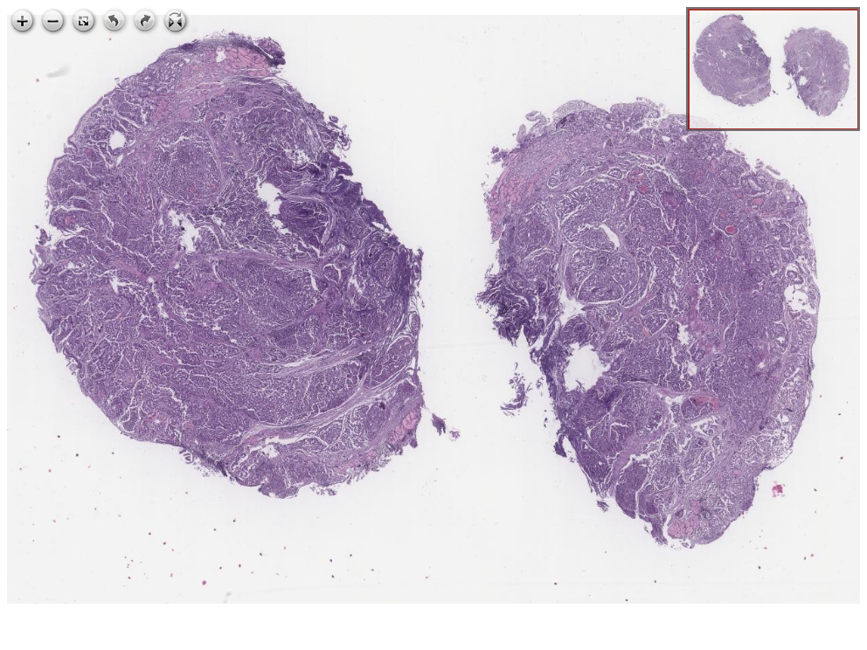](https://images.patolojiatlasi.com/ICE1-WDNET-duodenum/HE.html) [Click for Full Screen WSI](https://images.patolojiatlasi.com/ICE1-WDNET-duodenum/HE.html)

# References

# Appendix A — Katkıda Bulunmak İçin

H&E ya da özel boyalı preparatlarınızı bize elden ya da kargo ile ulaştırırsanız, onları tarayıp atlasa ekleyebiliriz.

Halihazırda taranmış preparatlarınızı bulut üzerinden [eposta](mailto:bilgi@patolojiatlasi.com) ile paylaşırsanız, onları da ekleyebiliriz.

Preparatın olduğu sayfaya eklenmek üzere

Adınızı,  
  
Kurumunuzu  
  
Yönlendirilmesini istediğiniz iletişim linkini (web ya da e-posta)  
  
Eklemek istediğiniz ek klinik bilgi, resim ya da notları

[bilgi@patolojiatlasi.com](mailto:bilgi@patolojiatlasi.com) adresine iletiniz.

Adres: Doç.Dr.Serdar Balcı Memorial Patoloji Laboratuvarı, Ortadoğu Plaza Kat:14, Kaptanpaşa Mah. Piyalepaşa Bulvarı, Okmeydanı Cd No:73, 34384 Şişli/İstanbul

|  |
| --- |
| Adres |

# Appendix B —

Please participate in the development of the atlas by using the comment section at the bottom of each page.

<https://www.youtube.com/watch?v=ONeGf4nYdPc>

# Appendix C — List

# Appendix D — List

1. [Tarık Atmaca](https://github.com/veterinarypathology3d) tarafından <https://veterinarypathology3d.com/> geliştirilmiştir.